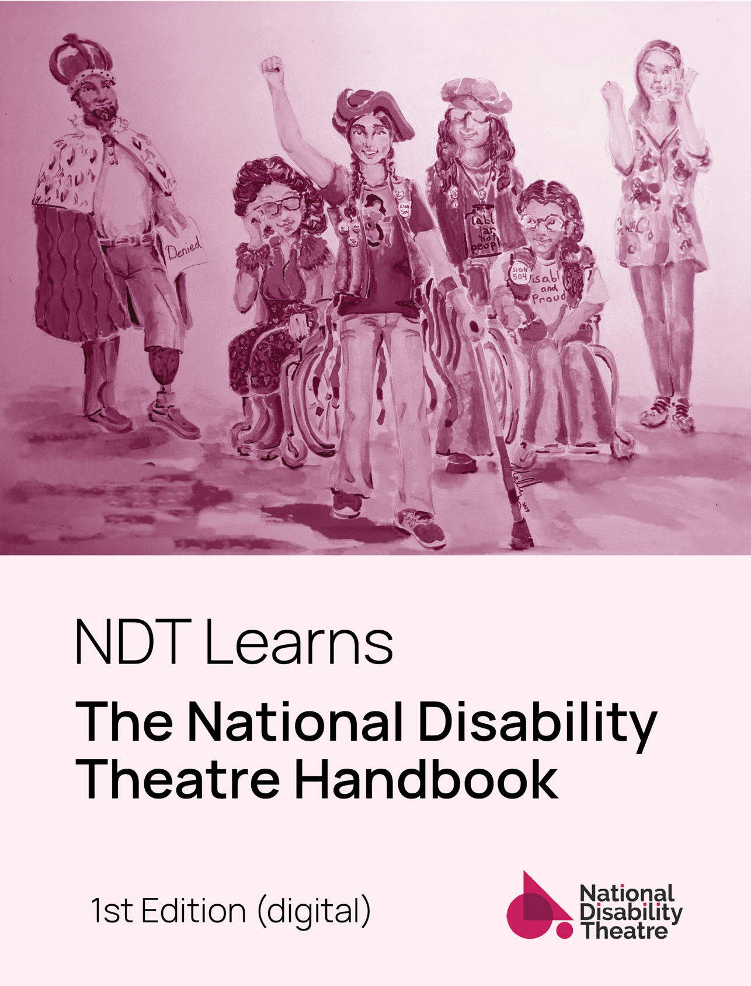

NDT Learns: The National Disability Theatre Handbook
1st Edition (digital). July 1, 2023.
Cover Caption: Costume and Character Renderings from “Emily Driver’s Great Race Through Time and Space” by A.A. Brenner and Gregg Mozgala. La Jolla Playhouse POP Tour 2020. Costume Designer: Mallory Kay Nelson
Cover Image Description: A hand-drawn image filtered in a gentle deep pink shows six people with light and medium skin tones. From L to R: a person wearing a red cape and crown and a prosthetic leg, a person in a wheelchair with sunglasses, a scarf and curly, styled hair, a person standing in the center with a rainbow tricorn hat, a braid of hair a t-shirt with an image of wonder woman in a wheelchair and a vest, holding a single crutch out in front, a person in a wheelchair with curly long hair and glasses with a t-shirt with “disabled and proud” on it, a button that says “504” and a puffy vest, and a person with straight, light hair wearing a flowery top, clasping hands together. Under the image the text reads: NDT Learns: The National Disability Theatre Handbook. 1st Edition (digital).
This work is available under a Creative Commons 4.0 CC BY-SA license. You may remix, adapt, or build upon the material, even for commercial use. You must license the modified material under identical terms, and credit “Talleri A. McRae, The NDT Handbook.” Contact Talleri McRae at talleri.a.mcrae@gmail.com.

Table of Contents
Table of Figures [fuchsia] iv
Contributing Artists [fuschia] vi
Prologue [fuchsia] 7
Land Back/Call to Action 7
Acknowledgments 9
Act 1: Setting The Stage [teal] 10
Guiding Questions 10
Scene 1: What this is, what it’s not; 10
Scene 2: Guiding Values 14
Scene 3: Perceptions of Disability 16
Scene 4: Words, Words, Words 20
Intermission: Disability Definitions [fuschia] 26
Definitions of Disability 27
Act 2: Access Planning [orange] 31
Guiding Questions 31
Scene 1: The Paradox of Preparation 31
Scene 2: Needs, Services, Supports 32
Scene 3: Thinking it Through 36
Scene 4: Planning Tools 41
Takeaways 46
Resources 48
Act 3: Access-Centered Practice [red] 49
Guiding Questions 49
An Access-Centered Aesthetic 49
Setting the Stage: Access Check-Ins 51
Scene 1: Show Selection/Season Planning 54
Scene 2: Production Elements 78
Scene 3: Theatre in Educational Spaces 90
Scene 4: Evolving from Early Covid-19 100
Intermission: Culturally Specific Practices [fuschia] 105
Deaf Theatre by Patty Liang of Deaf Spotlight 105
Relaxed or Sensory-Friendly Theatre by Craven Poole of Spectrum Theatre Ensemble 115
Act 4: Variations on Reflections [green] 129
Scene 1: Successes and Stories of Pride 129
Scene 2: Binaries, Spectrums, Tensions 135
Scene 3: Beautiful “Failures” 137
We back to me; beyond the 1st Edition 140
Curtain Call: Resources Snapshot [fuschia] 141
NDT Handbook Appendix 141
Further Resources 198
Works Cited 201
Note: Due to a technical limit between Word and Adobe, the Table of Contents could not display the color of each section. As a result, we have added the color of each section in brackets as an access hack.

Table of Figures [fuchsia]
Figure 1. Kristen Alesia and Azkara Gilchrist in “Richard III” Babes with Blades Production 2022. Photo: Brave Lux 59
Figure 2. Jai Ram Srinivasan (left) and Sebastian Ortiz play the role of Tiny Tim in “A Christmas Carol” on Broadway. Photo: V. Tullo for The NY Times Nov 14, 2019. 61
Figure 3. Phoebe Fico and Sean San José in CST’s “The Glass Menagerie.” Credit: CA Shakespeare Theater 2017. 63
Figure 4. Carolyn Agee, Mary Schaefer, Sydney Maltese in “Peeling” by Kaite O’Reilly, Sound Theatre Company, 2019. 65
Figure 5. Megan McGuire and Leonard Barrett in “Chicago”, Phamaly Theatre Company 2019. 67
Figure 6. “Fiddler on the Roof” at Phamaly Theatre Company, 2013. 69
Figure 7. “Emily Driver’s Great Race Through Time and Space” by A.A. Brenner and Gregg Mozgala. LJP 2020. 72
Figure 8. “We Love Like Barnacles” 2021: Nomy Lamm and Puppets, Sins Invalid. 75
Figure 9. Development workshop of “Emily Driver’s Great Race Through Time and Space” by A.A. Brenner and Gregg Mozgala. La Jolla Playhouse. 152
Figure 10. Development workshop of "Emily Driver's Great Race Through Time and Space" by A.A. Brenner and Gregg Mozgala. La Jolla Playhouse. 153
Figure 11. Emily Driver's Great Race Through Time and Space, the cast: From L to R, Paúl Arujo, Jaye Wilson, Cass Pfann, Farah Dinga. Photo courtesy of LJP. 154
Figure 12. "Emily Driver's Great Race Through Time and Space" by A.A. Brenner and Gregg Mozgala Photo courtesy of La Jolla Playhouse. Scenic: Sean Fanning 156
Figure 13. Abigail and Shaun Bengson in “Ohio” by The Bengsons. Actors Theatre of Louisville, January 2023. Photo Credit: Two Hearts Media–Yero 201
Figure 14. Ryan J. Haddad and Dickie Hearts in “Dark Disabled Stories” by Ryan J. Haddad,. The Public Theatre 2023. Photo Credit: Joan Marcus 203

Contributing Artists [fuschia]
Lead Author, Talleri A. McRae (online publication date: July 1, 2023)
Copy Editor: Amanda Lautermilch
Access Art and Dramaturgy: The Curiosity Paradox (Jonathan Paradox and Grant Miller)
Land Back/Call to Action: Crushing Colonialism (Jen Deerinwater)
Section Contributors: Deaf Spotlight (Patty Liang), Spectrum Theatre Ensemble (Craven Poole)
Interview Contributors: Claudia Alick, Evan Eason, Terri Lynne Hudson, Esteban Andes Cruz, Jacole Kitchen
Quality Reader: Sarah Kim
Feedback: Claudia Alick, Laura Cornwall, Regan Linton, Andrea Kovich, seeley quest, Meredith Aleigha Wells.
Digital Edition Cover Design: The Curiosity Paradox

Prologue [fuchsia]

Land Back/Call to Action
As a virtual organization, the National Disability Theatre (NDT) and the many who are involved are spread across Indigenous lands of communities that have been here since time immemorial. NDT was founded on stolen Coast Salish land, including the ancestral land of the Duwamish, Suquamish, Stillaguamish, and Muckleshoot People in Washington State, where 42 tribes share traditional lands and waterways, including 29 federally recognized tribes.
Those at NDT also reside on stolen Shawnee, Cherokee, Osage, Seneca-Iroquois, Miami, Hopewell and Adena land known as Kentucky. Funding for NDT has come from the stolen lands of the Lenape, Shinnecock, Poospatuck, Tuscarora, and the Haudenosaunee Confederacy-Seneca, Cayuga, Tuscarora, Mohawk, Oneida, and Onondaga known as New York where there are currently 8 federally recognized tribal nations.
There are other nations as well that do not currently have the colonial designation of federal recognition. Many of the Native people from these lands were the victims of genocide and removals committed by multiple colonizers pre and post creation of the so-called US. Due to urban relocation programs by the US government to further break up tribal communities and to steal reservation and trust land, there are Native people from tribal nations across the so-called US living in these areas today. New York City, a major hub for theater and the arts, has one of the largest urban Native populations in the so-called US.
Acknowledging the land non-Native people are upon is only a small, first step in the rematriation of the land and living in good relations with the Indigenous people and sovereign, tribal nations of the so-called US. An acknowledgement of stolen land will never be enough without the active efforts to return stolen, colonized lands and resources to the rightful stewards of said land. Land back rematriation actions can also include donations of time, labor, and services to local Native led organizations and nations.
This land acknowledgement and call for land back was written on the stolen homelands of the Nacotchtank and Piscataway people known as Washington, DC.
Jen Deerinwater, Founding Executive Director
Crushing Colonialism

Acknowledgments
To Disability Justice Culture Workers, Disabled Theatre Makers, and Disability-Led Theatres. From its beginning, NDT stood on your shoulders.
To NDT Staff members, Advisory Company members, Governing Board members, Work Group members, Anti-Racism cohort members, strategic plan interviewees, and supporters past and present. To La Jolla Playhouse, the 2020 POP Tour Artistic/Production Team of “Emily Driver’s Great Race Through Time and Space” by A.A. Brenner and Gregg Mozgala, Beyond the Divide Consulting, The Harriet Tubman Collective, Sound Theatre Company, Calling Up Justice, Indiana Repertory Theatre, and Actors Theatre of Louisville. To The FF, BF, and The WFT. To Jeremy Adkins and Kieran Adkins-McRae.
Without your time, energy, labor, support, or love, National Disability Theatre would not have been what it was.

Act 1: Setting The Stage [teal]

Guiding Questions
- What is this handbook? What is its purpose? Who is it for?
- What were the values of NDT over time?
- How is disability perceived and represented?
- What words do we use to talk about disability?

Scene 1: What this is, what it’s not;
This Handbook documents selected thoughts, ideas, and conversations that passed through National Disability Theatre from 2018 to 2023. Its primary audience is theatre professionals who work with—or want to work with—artists with disabilities. It is designed for folks who are new to access and for those who want to add to their existing access toolkits.
It is part Hand-book, part work-book, and part research. It is designed as a menu or a buffet; so select what works for you. You can stay at the surface, or dig deep. Glance at parts, take it in section by section, or jump around. Use it like a toolbox and a toy chest. Take what is useful for your most urgent access needs, and playfully consider new ideas when and if you have the bandwidth. Enjoy!

It is me; it is we
In disability-led spaces, one practice is to state your name as you begin speaking. So, to start, this is Talleri. The information shared in this Handbook has a point of view—mine—and is not neutral. It is both accurate and biased because it reflects my own lived experiences as a white, cis, straight, financially stable person who is living free, has access to healthcare, and identifies as a physically disabled “wobbly” walker (diagnosis identity: cerebral palsy, CP).
Within single-issue disability advocacy, white people with physical impairments have historically received a lot of “air time.” At the same time, disabled folks who are
- Black, Brown, Indigenous, Trans, Queer, or a Person of Color
- communicate in American Sign Language (ASL) or Augmentative and Alternative Communication (AAC)
- are neurodivergent
- can’t always accurately predict how much energy a task or endeavor will take
- identify (or don’t identify) as mad, sick, or ill
have been less visible in mainstream disability advocacy and in disability theatre.
In order to address this, one of NDT's main goals was to shift the model of a single access consultant or a performer into a community, an ensemble. This Handbook imperfectly attempts to go beyond “me” to be “we.” The “we” in this Handbook is aspirational, generous, and broad. “We” is not, however, a blanket statement about all disabled people, all theatre-makers with disabilities, or “all” anything. “We” holds the ideas that passed through the leadership at NDT.

It centers disability; it is more than disability
We named ourselves National Disability Theatre to encourage theatres to hire disabled artists. From its founding, NDT believed access helps everyone and makes everything, including art, more interesting, dynamic, and human. As time went on, our general idea of “access helps everyone” got even more specific, thanks to Sins Invalid’s 10 Principles of Disability Justice, including cross- disability solidarity and cross-movement solidarity. While this Handbook centers access for individuals who identify as disabled, this Handbook will also pose questions to readers about collective access in a way that includes more than disability.
In this Handbook, we will ask:
- How can access for disabled folks intentionally include other forms of access, like language, class, racial, and cultural access, for example?
- How can disability show up in various contexts and cultures? How can oppressions compound?
- How can access support all folks, disabled or not?
- How can access intentionally support disabled people experiencing multiple marginalizations?

It is not a checklist; it has lists
In Peoples Hub’s Disability Justice and Access Training and Support Group, “Access is not a checklist but a politic and a practice.” This document is a practice, a rehearsal; it is trying something new. It is repetition and refinement. In our experience, access is not a checklist because it is not a binary “yes” or “no,” but a process. Like most theatrical endeavors, it is a collection of trials and errors, of celebrations and reflections.
Not everything we mention has been tried, and not everything we tried will be mentioned. The lists we share are good places to start, but not to end. So use the lists, but don't feel beholden to them– adapt!! We invite you to say, "Yes, and…" then get creative.

Scene 2: Guiding Values
Over time, NDT articulated, and re- (and re-) articulated its organizational values. We strove to connect our values to policies, procedures, and programming. Again and again, NDT returned to four main ideas– Collaboration, Choices, Communication, and Creativity. The Appendix has a summary of NDT’s timeline and values.

Collaboration
Much of NDT programming was facilitated by at least two disabled folks with diverse lived experiences. Rather than ask a single voice to represent multiple experiences, NDT brought many people together. We considered their disability, culture, race, class, gender, and artistic identity.
Furthermore, disability advocacy can include not just adult disabled activists, but also parent advocates and service providers. NDT believed in centering people with direct lived experience of disability, but encouraged theatres to be open to a variety of perspectives and opinions. One rule was, “if a group doesn’t disagree with each other, it isn’t big enough.”

Choices
Rather than having “one way” of doing things, NDT believed that offering a minimum of two choices (or a small menu of options) whenever possible would empower disabled artists and artisans to choose what works best for them.This practice can ultimately improve the process for all involved. Furthermore, designing a menu of options can encourage producers and hosts to shift the pace of their work and slow down–this is called Crip Time in disability culture. Act 2 scene 4 dives deeper into Crip Time.

Communication
NDT encouraged folks to communicate about access as much as possible–internally, externally, in advance, and in detail. In our 2022 partnerships, we invited organizations to communicate directly with disabled artists to ensure artists would be considered ongoing collaborators, not one-time consultants.

Creativity
Central to NDT’s mission was the idea that providing access and making access-centered art are not separate, but intertwined processes. And the outcome is widely creative. Our disabilities and our access needs are part of a specific artistic aesthetic. Act 3 dives deeper into what we mean by an Access-centered Aesthetic.
We will loop back to these four C’s–Collaboration, Choices, Communication and Creativity–as touchstones throughout the various sections of this Handbook. We invite you to do the same, as you strive to center all kinds of access in your own work. How are you collaborating? Offering choices? Communicating in multiple ways? Getting creative?

Scene 3: Perceptions of Disability
Before we can dive into any of the nuts-and-bolts practical offerings of making theatre with disabled folks, let’s consider the concept of disability itself, and how it is perceived within society–both now, and in the past.
There are many common views of disability in mainstream culture today. We’ll start with views that categorize disability as a problem to be judged, pitied or fixed. Then we’ll move on to views that acknowledge how social, cultural, and systemic norms can shape disability. The section may start out feeling familiar, then get more complicated as we go. Don’t feel the need to read straight through, or process every view presented.
For more tools to consider views of disability, the first Intermission explores various definitions of disability, and Act 3 offers a deeper dive into representing disability responsibly.

Individual: Moral, Charity, Medical Assumptions
Many views of disability in society assume disability is a bad thing to be judged, pitied, or fixed. Not only do these views define disability through a deficit lens, they also frequently leave out Black, racialized, poor, and other marginalized experiences of disability (Schalk, p. 133).

Moral Assumption
Disability or difference is judged as a character flaw.

Pity/Charity Assumption (Inspiration Porn)
Disability is reduced to being an object of pity in need of charity to survive.
This view of disability is often called “Inspiration Porn” because it objectifies disabled bodies and minds to make non disabled audiences feel better about themselves. Think of any movie where the disabled character exists primarily to help a nondisabled character grow into a better person. For more thoughts on Inspiration Porn, see Chapter 4 of “Demystifying Disability” by Emily Ladau.

Medical Assumption
Disability or difference is a problem to be fixed or cured.

Collective: Social, Cultural, Intersectional Views
What if disability is not a bad thing, but a tool for good? What if disability is an innovative, joyful experience? What if disability offers skills and tools to dismantle systems of oppression? Consider the overlapping and intertwined views of disability below:

Social View
Disability is situational. It is created by society's failure to support people who do not meet current societal norms.
In theory, this view moves away from the concept of disability as an individual trait and focuses on accessible environments. In practice, mainstream access requires many individuals to adapt to their environment, most often with the help of non disabled people.

Cultural View
Disability is a form of cultural diversity with its own arts, languages, and customs.
This celebrates disability as human diversity and innovation. The idea of “disability pride” is hugely beneficial to many, yet often it narrowly focuses on disabled people who also hold racial and class privileges. Furthermore, it can dismiss or erase experiences in which being “out” as disabled could be harmful or dangerous.

Intersectional View
Disability intersects with other forms of oppression, such as racism, sexism, homophobia, transphobia, and classism, and is shaped by broader social and political structures that perpetuate inequality and discrimination.
For example, Jen Deerinwater, Founding Executive Director of Crushing Colonialism, observes that “American Indian and Alaska Native people have the highest rates per capita of disabilities in the so-called US, and yet very few people in the Disability community, especially the disability rights community, are advocating and fighting for Native rights” (2023).

Political/Relational View
Disability is relational and a product of both embodied experience and socially experienced power differentials.
The Political/Relational view holds space for complex realities of people’s disabled experiences, and “situates disability squarely within the realm of the political” (Kafer, pg. 9) by acknowledging the impact of power differentials in the disabled experience, as well as contextualizing historic and political meanings of disability.
Vilissa Thompson, a Disability Justice culture worker interviewed for “Black Disability Politics, speaks to these power differentials, reflecting that “race plays a very big role in disability [with] who can get support and services, who doesn’t and why, who gets mistreated and why” (Schalk, 135).

Scene 4: Words, Words, Words
Many people hesitate to start a conversation about accessibility and disability because they do not know the “proper” and “respectful” words. The result of striving for the “perfect” language is often silence and exclusion. Author Tema Okun reminds us that a goal of doing something “perfectly” is a tool of white supremacy. Instead, she encourages folks to operate from a mindset of appreciation, growth, and learning (Okun, 1999). So, say something. Let your understanding evolve. Try again.

Words that can halt access
Words that, when describing individuals, reflect the Moral, Pity/Charity, and Medical assumptions of disability take the focus away from collective access. Consider:
- afflicted with (moral assumption)
- differently-abled or special needs (pity/charity) and
- confined to or suffering with (medical assumption)
Words like this keep disability within individual bodies and/or minds. NDT recommends using them only if preferred by a disabled person referring to themselves.

Words that can propel access forward
NDT most often started conversations about language with two words that reflect the social view of disability:
- accessibility
- “reasonable” accommodation
The word accessibility refers to an environment instead of individual diagnosis, or impairments. And, “reasonable accommodations” are tools that make spaces accessible. These words have legal weight (see the first Intermission) and should be used when needed. Yet the reality is that many places offer accommodations as a top-down afterthought. Providing them feels like “extra” work. While the words accessibility and accommodation are good starting points, they are incomplete.
NDT learned that many intersectional social justice spaces using the principles of Disability Justice have slightly different language from the rights-based framework of accessibility and accommodation. Consider these seemingly small yet big shifts in language below that move us from individual to collective access:

Access Needs (accommodations)
Disability Justice activist Ki’tay Davidson said of access needs, “We all have needs. The difference between the needs that many disabled people have and the needs of people who are not labeled as disabled is that non-disabled people have had their dependencies normalized” (Davidson, 2015). So, instead of singling out people who identify as disabled as needing accommodations, access needs are something that we all have, and we can all support.
Act 2 has more information about Access Needs.

Access-Centered (accessible)
If your two options are to make a space accessible or not, you either pass or fail. Many disability rights-based efforts to provide accessibility echo the charity assumption of disability by using a give/receive binary. In other words, non disabled people provide individual accommodations, disabled people use them.
However, if your goal is to make a space access-centered, there’s a spectrum of more and less access. Access is not as simple as give and receive; it is complex, messy. And, the larger the gathering of people, the bigger the chance is for competing or conflicting access needs.
In access-centered work, it’s not always possible to meet all needs all of the time. On the contrary, access needs will be prioritized, tended to, and implemented by the group in big, small, formal, informal, and imperfect ways.

Disabled People and/or People with Disabilities
To start, don’t be afraid to use the word disability to refer to a group of people, a community. Using identity-first (“disabled people”) and/or person-first (“people with disabilities”) language depends on context and may shift often. Jacole Kitchen, La Jolla Playhouse’s Artistic Programs and In-House Casting Manager says, “I make sure to put both phrases, “disabled actors” and “actors with disabilities”, on casting calls, to communicate that artists are welcome to identify in more than one way.”
Ask for feedback, learn, and give people the grace and space NOT to use the word disability at all. Disability Justice culture workers like Dustin Gibson remind us that insisting on or using words like “disability” and “disabled” are not the most important thing. The goal is to ultimately provide liberation, safety, and care for everyone no matter how people identify (Schalk, 134).

Takeaways
Claudia Alick, the curator of 30 Days of Racial and Disabled Justice, a collaboration between NDT, Sound Theatre Company, and Calling Up Justice, frames language as a flexible and evolving tool. Claudia shares: “The words we use to describe concepts begin evolving the moment we put them into use. They are defined, refined, co-opted, and/or redefined as culture shifts and society grows” (Alick, 2021). Language changes in different contexts. Claudia’s key takeaways:
- Always listen to marginalized people describe themselves and use their preferred language
- Do not aim to memorize the “right” words or to police others' words. This misses the forest for the trees
- Familiarize yourself with concepts in order to build a shared vocabulary and analysis with your community
- Communication is a mix of what you are literally saying, what you mean, and how it is received
If we follow Claudia’s advice and contextualize the language we use, we can ask ourselves:
- What words do disabled people use to describe themselves? Individually? In advocacy groups?
- What words reflect the Moral, Pity/Charity, and Medical assumptions of disability?
- What words support the Collective, Social, Cultural, Intersectional, and Political views of disability?
- How and why do these words shift over time?
- How might language harm others? How can we make space for multiple experiences of the same word?

Resources
For more information about practical uses of the word disability, check out Chapter 1 of Emily Ladau’s book “Demystifying Disability.

Intermission: Disability Definitions [fuschia]
When many people first worked with NDT, they were hesitant to use the word disability. If you’re a word-nerd and love thinking about different ways words function, below are some conversation starters. Consider:
- If you met someone who did not know the word, what would you say “disability” is?
- Would your explanation change if the person spoke a different language and/or was from a different culture? A different race? A different class?
- When and where do you come across the words “disability” and “disabled” most often? Are they spoken aloud, whispered discreetly, both, or neither?
The next section takes a deep dive into many definitions of disability. Take what makes sense, leave the rest.

Definitions of Disability

Legal – The Americans with Disabilities Act (ADA)
The ADA defines disability as:
- A physical or mental impairment that substantially limits one or more major life activities of an individual
- A record of such an impairment
- Being regarded as having such an impairment
According to the ADA, disabilities can be permanent, temporary, or episodic. This legal definition is important–it often entitles people with documented disabilities to use “reasonable accommodations” like services, support, and insurance (Department of Labor, n.d.).

Artistic – Kevin Kling
Disabled playwright and storyteller Kevin Kling observes that in Greek mythology, humans and gods are separated by the River Styx. For Kling, to have a disability is to have “a foot in two worlds” (2014), one in the underworld, and one above. Thus, Kling points out that the prefix of “dis,” does not mean, “less than;” it means “separate.”

Aesthetic – Sins Invalid
The members of Sins Invalid, a collective of disabled artists based in northern CA, describe one facet of disability identity as aesthetic, artistic. Their work nurtures an aesthetic vision in which all bodies are seen as valuable and beautiful (Berne and Harwell, 2021).
Act 3 has more information about a Disabled or an Access-centered Aesthetic.

Ableism – TL Lewis
Below is a working definition by Talila "TL" Lewis in conversation with Dustin Gibson and other Disabled Black and otherwise negatively racialized folks from Jan 2021:
A system that places value on people’s bodies and minds based on societally constructed ideas of normalcy, intelligence, excellence, and productivity. These constructed ideas are deeply rooted in anti-Blackness, eugenics, colonialism, and capitalism. This form of systemic oppression leads to people and society determining who is valuable and worthy based on a person’s appearance and/or their ability to satisfactorily [re]produce, excel, and "behave." You do not have to be disabled to experience ableism.

Disableism – TL Lewis
NDT spent several hours with TL Lewis and Dustin Gibson of the Harriet Tubman Collective in Fall 2020. During that time, TL shared a definition of ableism (above) as well as a more specific type of discrimination: disableism. TL defined disablism as discrimination that assumes disabled people are inherently dependent and need to be fixed, cured, or made ‘normal’ by non disabled people.
In practice, many disabled people with other areas of social privilege (like race and class privilege) use the word “ableism” when they are really describing the more narrow, yet still relevant issue of disablism.
Act 4 has more about NDT’s Anti-Racism Intensive .

Takeaways
Now that you’ve reviewed the definitions above, how might your understanding of disability shift? Remember, not all people with access needs identify as disabled, and not all disabled people have formal diagnoses and/or access supports.
In “Beasts of Burden”, Sunara Taylor reminds us “disability can be an identity one embraces, a condition one struggles with, a space one finds liberation in, or a concept that can be leveraged to marginalize and oppress. It can also be all of these things at once” (2019).
As you reflect on the word disability, consider:
- When might the legal, rights-based framework for disability be useful for individuals and organizations?
- When might the word “disability” be liberative and grounding?
- When might the word “disability” be oppressive and harmful?
- How might the artistic definition encourage people to celebrate disability as a diverse human asset?
- How can we further explore a disabled aesthetic?
- How can we address access in medical, healthcare, social, cultural, and spiritual settings without ever using the word “disability”? (Schalk, introduction)

Act 2: Access Planning [orange]

Guiding Questions
- What do you need to know to provide access?
- What tools can help meet people’s access needs?
- How do people navigate the realities of access and address the myth of “perfect” planning?
- How can you balance proactive planning with the trial-and-error nature of collaboration?

Scene 1: The Paradox of Preparation
The tools in this section are starting points, not ending points. They are invitations to understand individual and communal access needs that constantly change.
Like the production process, access is a dance of preparation and improvisation. Any scene partner will share that rehearsal involves both solo work and group work. Access is no different. There are things you can do solo–things to learn, articles to read–and things to do in community. This chapter offers a few ideas for how to get started, either solo or in groups.
While preparation is key, don’t wait until your entire building is accessible. Until your entire staff is thoroughly trained on exactly what to say/do. You’ll always be waiting. If you’ve thoughtfully explored best practices but have not yet taken action, go for it! Aim for possible, not perfect. (McRae with Linton and Holt, 2017)
“Perfect” access, where every single person’s access needs are met all of the time, is a myth. Rather, most access success stories include people who are willing to “workshop.” They try new things, reflect on what worked (and more importantly what didn’t work), navigate conflicting access needs together, and revise. If you are doing it right, access will be a beautiful, messy paradox.

Scene 2: Needs, Services, Supports
The terms access needs, access services, and access supports are often used interchangeably, but in fact, they are three distinct concepts worth exploring.

Access Needs
Remember from Act 1 that all people, disabled and non disabled, have access needs. Some needs are met automatically by society, others are not. But what is an access need? An access need:
- Arises from an interaction between a person and their environment
- Is what is required in order to communicate (input and output) and participate in a given setting
Access needs can be big or small, temporary or permanent. While many people think about access needs as being physical, they can also be sensory, social, cognitive, intellectual, or communication-based.
What tools do we have to meet people’s access needs? One option is to implement Access Check-ins. Act 3 has more information on Access Check-ins. For now, read on.

Access Services
Today, many performing arts and other cultural venues offer formal access services to audiences, including:
- Assistive Listening Devices
- American Sign Language (ASL) Interpretation
- Audio Description
- Guided or Tactile Tours
- Captioning (open or closed)
- Accessible Seating
- Sensory Friendly or Relaxed Performances (The second intermission has more information about Sensory Friendly/Relaxed performances.)
If your organization doesn’t currently offer these services, NDT would encourage you to research the monetary and staff input (including time) involved, and work with providers to offer ethical compensation within your budget. To find service providers, the Appendix has a list of local and regional cultural access consortiums.
In many ways, access services are great! However, while venues offer these essential services to audiences for performances, they rarely offer them to staff during work days or to artists in rehearsal. Furthermore, when offered to audiences, access services can be under-used. Why?
One reason is that the access services above are often implemented with minimal or narrow input from their intended users. Therefore, any given access service may or may not meet the access needs of audiences, let alone of artists, administrators, or collaborating partners.
Another reason is that access services are usually added on after a performance has been created and solidified. This can make them feel like “extra” work. There’s more about incorporating access services into production design in Act 3, Access-centered Aesthetic.

Access Supports
While access services can be provided with little to no input from the user, an access support actually meets an access need. Access supports may include formal access services, like open captioning at a performance, but also could be access to a script to read along. It could be social acceptance from house staff, performers, and fellow audience members to use a personal device, like a phone, to generate auto captions.

Example: Restroom Support
"Care Work" asks and answers a practical question: What if we don’t have accessible restrooms? (2021, pg. 93).
While more formal access services might mean building renovations, access support suggestions in “Care Work” offer a menu of options:
- Take the door off its hinges and hang a curtain
- Rent an accessible port-a-potty
- Partner with a nearby building–a restaurant, church, gas station–to use their accessible restroom
So, how do theatres start by offering essential access services and build on them to support community access needs? To truly support access? Keep reading!

Scene 3: Thinking it Through
To encourage organizations to start thinking about access in a concrete way, NDT asked collaborators to join us in an exercise that we learned from access consultant Diane Nutting. The questions below evolved over time. We hope that they will serve as a baseline for you to add, subtract, edit, or update as needed.
Think about a recent arts event you participated in–at first, think as an attendee. Try not to pick an event you had to go to for work, but one you chose to attend. It could have been virtual, in person, or hybrid. Consider:
How did you find out the event was happening?
- Online?
- Through Social Media?
- A friend or colleague?
- Email?
- A paper flier or snail mail?
How did you decide whether or not to attend?
Did you consider:
- Cost?
- Internet connectivity or reliability?
- Computer hardware or software?
- Transportation? (public or private, solo or shared?)
- Weather?
- Your energy levels and/or bandwidth?
- Company or social support?
- Caregiver needs for family, friends (children, adults)?
- Your clothes?
- Schedule?
- Food/meals?
- Allergens? (food- or chemical-based)
- Type of restroom? Location of restroom?
- Illness exposure risk?
Once you decided to go, how did you confirm?
- Buy a ticket?
- Make an online reservation?
- Visit a box office in person?
- Coordinate tickets or reservations with others?
Once you decided to go, what did you have to plan?
- Transportation? (public or private, solo or shared?)
- Weather?
- Your energy levels and/or bandwidth?
- Caregiver needs for family, friends (children, adults)?
- Your clothes?
- Your schedule?
- Food/meals?
- Allergens? (food- or chemical-based)
- Masking and/or testing?
The day of, what did you circle back to, confirm, or solve?
Once you arrived, how did you know what to do?
- Was your transportation drop off nearby or far away?
- Did you find your way solo or with others?
- Were you practicing physical distancing?
- Did you need to find the box office?
- Did you need to find a usable restroom?
- How did you know the event was starting?
During the event, how did you know what was going on?
- Were there visual cues you could see?
- Verbal or other audio cues you could hear?
- Tactile cues you could feel?
During the event, how did you know what to do?
- Could you move freely?
- Make noise?
- Use electronics?
- Ask questions? Take turns?
- Get up and sit back down again?
- Use the restroom and return?
- Participate physically with your body?
- Participate verbally with your voice?
How did you know the event was over?
What did you need to do to make your way back home?
As you thought through your own experience, what access barriers were there? What offered you access support? What information was good for you to know ahead of time, as you are the expert of your own needs?
Repeat this activity thinking about roles beyond attendee (e.g. actor, director, designer, student, etc) who may be participating in an interview, audition, or rehearsal. What do you as a host already know about venue options, processes, or projects that can offer access support?
Ask yourself, what info could be shared in advance about:
- the physical or digital space?
- the sensory environment?
- the information/intellectual environment?
- the social expectations?
- the agenda or schedule?
- the health and safety precautions?
While doing this activity, you might feel curious about the access needs of people who encounter different barriers than you do. If this happens, be mindful of the pity/charity assumption of disability and the give/receive hierarchy of care. While some curiosity is natural, too much can cross a boundary. Be curious, but don’t be intrusive. Remember that the process of identifying and naming access needs is deeply personal. Furthermore, it is almost always unpaid emotional labor. Building trust to communicate access needs can take weeks, months, or years.
Disability Justice culture worker Mia Mingus describes “access intimacy” as the feeling when your needs are met in a seemingly effortless way (2011). Access intimacy is taking care of someone with the exact balance of support, collaboration, and care. By contrast, forced intimacy occurs when a person feels pressured to name an access need when they are not comfortable or ready to do so. As you build relationships, be aware of forced intimacy and strive instead for access intimacy.
For more about access intimacy, see Act 3; Access Check-ins.

Scene 4: Planning Tools

Universal Design, Universal Design for Learning
Universal Design (UD) is an architectural concept that harnesses the social view of disability. UD’s principles answer the question: If many disabilities are defined by our environment, then how can we create spaces that are as accessible as possible? The characteristics of Universal Design are:
- Equitable use (can lots of different people use it?)
- Flexibility in use (can people use it in different ways?)
- Simple and intuitive (do people know how to use it?)
- Perceptible information (do people understand?)
- Tolerance for error (does trial-and-error work?)
- Low physical effort (does it use energy? Endurance?)
- Size and space for approach and use (is it usable?)
Similarly, Universal Design for Learning (UDL) is a set of principles designed to make learning environments, products, and services as accessible as possible. UDL encourages flexible options for:
- Engagement: How do people personally connect to learning material?
- Representation: How do people take in information?
- Action and Expression: How do people express their responses to the information presented?
For example, a UDL approach might involve 1) providing materials in multiple formats (e.g. text, audio, and video), 2) offering choices for how folks demonstrate their knowledge (e.g. through writing, speech, or visual representation), and 3) providing multiple ways for folks to engage with the material (e.g. through discussion, collaboration, and/or independent work).
Like the other tools we’ve discussed, UD and UDL offer starting points, not ending points to access-centered work. When used in isolation, these tools are static, often overwhelming checklists that can reinforce a give/receive binary, not a dynamic practice. NDT learned that by itself, like many single-issue advocacy tools, UDL doesn’t always address less visible disability experiences (like chronic illness) or dismantle broader social structures designed to marginalize people.
In our experience, the most effective use of UD and UDL is to pair it with improvisational, community problem solving and by embracing a trial-and-error approach. UD and UDL can help you be prepared, but also be ready to improvise in the moment.
To learn more about Universal Design for Learning, check out Act 3; Scene 3, Theatre in Educational Spaces and the Appendix has a UDL Sample Lesson Outline.

Variations and Translations
Cleveland-based Dancing Wheels embraces the concepts of “variations” and “translations” to explore how dance moves can live on many different kinds of bodies. NDT borrowed these concepts from the disabled dance world because they are dynamic, artistic, and playful. While the concept of accommodations can reinforce an imbalanced binary of giving and receiving, variations and translations are equitable among each other. There’s no one way to do variations and translations; there are endless possibilities.

Example of Variations
Variations of a pirouette could be a standing pirouette, a sitting pirouette, or a pirouette supported by a crutch, a walker, or another dancer. For more examples of Variations, see Act 3; Scene 3, Theatre Games.

Example of Translation
Translating words from one language to another is not just a science, it is an art. When “translating” movement, words, ideas, or concepts among a variety of bodies and minds, things will be lost in translation. Yet, the process of translation remains valuable.
Dancing Wheels offers audiences multiple translations for how to experience dance, including through verbal description, transcription, and demonstration rather than relying solely on visual cues.

Crip Time
Crip Time as an in-group phrase among disabled folks that acknowledges the flexibility we need to move through the world in our bodies and minds. This need for “extra” time makes space for disabled realities like slower movements, reduced stamina, or need for more processing time. It also honors the time and energy needed to navigate things like inaccessible environments or limited transit options. In other words, the process of going and being for people with disabilities can be more time consuming than non disabled schedules allow.
In mainstream theatre, time is often exact. Auditions are timed, curtain goes up at 8 pm sharp, break is over at 5 minutes to the second. These practices are supportive to some folks who thrive on predictability. They have long been called “professional.” At the same time, these practices can be oppressive and exclusive to many of us whose bodies and minds can’t conform to exact times. Consider some ways theatres can embrace flexible Crip Time, with at least two choices for:
- Flexible start and end times for auditions, rehearsals, breaks, performances, and intermissions
- Callback policies with access to scripted material days in advance, and multiple days in between general auditions and role-specific call backs
- Humane rehearsal schedules (5 day-weeks, 5-6 hour days with lots of breaks) with options for attendance
- Flexible seating and attendance policies that allow artists and audiences to come and go as needed
If your rehearsal or performance is shifting from rigid time to flexible time, consider sharing the “why” of this information with artists and audiences. You might say: “Our intermission will be between 10 and 15 minutes to ensure everyone’s access needs are met.”

Takeaways
Let’s return to NDT’s values as we reflect on ways to support access planning:

Collaboration
- What do we already know about the community we want to work alongside? What do we want to know?
- What can we learn by ourselves? In community?
- How can we compensate people for the emotional labor (time and energy) they expend while planning?
- How can we get to know people’s individual and collective access needs, services, and supports?
- What behavior might we experience that we may not understand?

Communication
- What detailed information (physical, sensory, social) can I share about a venue or experience in advance?
- How can the information I share use multiple formats and modalities? (words, pictures, both)
- How can I ask for feedback before, during, and after?

Choices (Formats and Modalities)
- Can we design at least two choices for participation?
- Can we be flexible? How?
- What tools, including UD, UDL, and strategies like Variations and Translations, can offer support?
- How can communication and programming include choices or a menu of ways to be and do, including:
  - Words
  - Movement
  - Pictures/Images and Image Descriptions
  - Clear Signage (words and pictures)
  - Videos with captions and audio description
  - ASL, BASL, and/or Tactile Signed English (TSE)

Creativity
- How can we approach access planning with the same confidence, curiosity, and creative problem-solving that we bring to our work in the theatre every day?
- How can the ways in which we provide access be part of our art, not separate from it? More on this in Act 3, Access-centered Aesthetic.

Resources
Below are some of NDT’s go-to resources for planning. The Appendix has a draft of NDT’s Resources Webpage.
- Skin, Tooth, and Bone: A Disability-Justice Primer (2nd Edition) Access Suggestions for Public Events, page 28-41.
- A Disability Justice Audit Tool
- HEARD How to Offer Access-Centered Organizing
- Access Living: Planning an Accessible Digital Event
- Phamaly Theatre Company’s Accommodation Recommendations

Act 3: Access-Centered Practice [red]

Guiding Questions
- What is an Access-centered or Disabled Aesthetic?
- What are Access Check-ins? How do people do them?
- What tools support access in various spaces and at various steps in production? In educational spaces?
- How can we evolve from making theatre during Covid-19?

An Access-Centered Aesthetic
An Access-centered Aesthetic is the idea that access is not separate from our art, it IS the art. Consider:
- Gear (crutches, chairs, canes, prosthetics)
- Architecture (ramps, railings)
- Services and supports (captioning, ASL, etc.)
- Medications, snacks
- Schedules and pacing
These things are not just logistical elements, but artistic building blocks. They are both functional and artistic.
This concept is not new or futuristic. Many scholars have written about it, including Tobin Siebers in the aptly named “Disability Aesthetics” (2010). Artistic collective Sins Invalid names their specific aesthetic vision in which all bodies are seen as valuable and beautiful. Phamaly Theatre in Denver CO and Open Circle Theatre in Washington DC have been telling familiar stories with a disabled lens for decades.
At NDT, we called an Access-Centered Aesthetic many things. A Disability Aesthetic, A Disabled Aesthetic, Crip Storytelling. At one point, we borrowed the phrase, “Disability gain,” from Sean Fanning, our set designer identified as D/deaf. Sean riffed on “Deaf Gain” to describe a kick ass double wheelchair car.
The sections below are a variety tools to build an Access- centered Aesthetic. We start with Access Check-ins, which can be done at any time. Then, we dig deep into show selection and go through the production process (auditions, rehearsals, performances). Next, we offer ideas for educational spaces (classes, theatre games) and end with a section on how early Covid-19 protocols offer not just logistical justice but artistic possibilities, if carried into the future. Sections switch between introductory ideas and deep dives. Jump around. Sample small sections. Take what you need, leave what you don’t.

Setting the Stage: Access Check-Ins
Access Check-ins are a collection of ways for people (whether or not they identify as disabled) to share their access needs and support the access needs of others. Check-ins can help folks realize what their needs are, how their needs may shift in various settings, and how their needs may already be met.
In theatre, producers, directors, stage managers, and others can check in about access needs in lots of ways:
- On an audition or registration form
- Within an employment agreement (access rider)
- During auditions, interviews, or meetings
- As part of classes, rehearsals, and tech
- At the beginning of a performance or curtain speech
When NDT partnered with La Jolla Playhouse (LJP), LJP regularly checked in (in words and in person, formally and informally) about access needs. Pre-pandemic, they hosted hybrid events and experimented with payment types, payment schedules, and creative housing.
One way to do an Access Check-In is at the beginning of a gathering. On a Zoom call, I might say:“Talleri speaking, she/her pronouns. I am a white woman with brown hair with gray highlights in a blue shirt. My access needs are met–I am sharing space with a six year old today.”
Instead of using Access Check-Ins to single out people who identify as disabled, Access Check-Ins can remind us all that we all have and can support each other’s access needs, both met and unmet.
Some individual access needs might be:
- “Captions are on. My access needs are met.”
- “I may need you to repeat your instructions.”
- “I need a digital copy of the script.”
You can name physical, sensory, emotional needs:
- “I need to attend today’s rehearsal via Zoom.”
- “I need patience; I am in the midst of a life transition.”
- “None of us sign. We need certified ASL interpreters at rehearsals with our Deaf guest artists.”
Spectrum Theatre Ensemble uses two questions:
- What do you need?
- What do you have to offer?
"Care Work" offers: What feels possible today?
Finally, Access Check-ins can be joyful:
- Music in the Zoom is playing on low. Everyone dances with each other before a word is spoken.
- “Let’s start rehearsal with our name/ pronoun chant!”
- “Stop the meeting! You’re on a TV show? Say more!”
In their article, “Access Check-Ins For Facilitators: Reinvent the Wheel Every Time,” Grant Miller and Jonanthan Paradox Lee of The Curiosity Paradox remind us that “Access Check-Ins are a way to rehearse enjoying space with others. When used repeatedly over time with the same groups of people, you can build Access Intimacy with others” (2023).
During its tenure, NDT hosted lots of Access Check-ins, and while they didn’t always go smoothly, we kept trying. NDT learned that truly supportive and connective Access Check-Ins had similar characteristics. They:
- Offered choices
- Set their own pace; they used Crip Time
- Were dynamic and caused change; Agendas shifted
- Balanced predictable structure with flexibility
- Invited people to share, but didn’t demand it
- Humanized and connected people
Disabled artist Estaban Andres Cruz reflects, “Access Check-Ins are a clear sign of a process’s commitment to being human, of sharing love . If you’re not in the business of love, you should stop doing theatre.”
Similarly, La Jolla Playhouse’s Artistic Programs and In-House Casting Manager Jacole Kitchen says, “It doesn’t matter what words you use; creating a space where people can name their needs helps everyone and everything–artists with disabilities, artists without, audiences, and the story you are telling. Meeting people where they are is key.”

Scene 1: Show Selection/Season Planning
In Act 1, we referenced a handful of societal views of disability–ways that disability can be located individually, socially, and culturally. Now, we’ll look at some possibilities for theatres to approach disability from a variety of ways, starting with Show Selection/Season Planning. This scene offers examples of and tools for understanding disability representation in pre-existing scripted work. Other approaches to disability representation, including commissioning new works and hiring disabled directors and designers,is in scene 2, Production Elements.

Representing Disability Responsibly
This scene will return to the views of disability that we introduced in Act 1. This time, we’ll take a deep dive, and offer some ideas and nuances about disability on stage. Some of these ideas we’ve been talking about for years, some are newer to us, and we’re excited to share!
Each page will have:
- A one sentence description of the Disability View from Act 1
- An example with
  - Image from a production
  - Image description and caption
  - A description of how that production addresses disability representation in a dynamic, exciting, innovative way
SPOILER ALERT: The answer is hiring disabled artists. Not just one. Lots of us. At the same time.
We’re right around the midpoint of this Handbook. This section–with pictures–should give off sexy centerfold vibes! Look at these disabled artists! Look at these stigma-reducing disabled ensembles! Look at that Access-centered Aesthetic! Ooooh, aaahhhh, ohhhhhhh…….

Moral Cliché
Disability is judged as a character flaw.
One example of this is… Shakespeare’s “Richard III.”
One way to combat this is… casting/hiring multiple disabled people! In 2022, The Public Theatre in New York City cast several disabled artists, and Babes with Blades in Chicago had a disabled ensemble and a creative team led by a disabled director. (Figure 1)
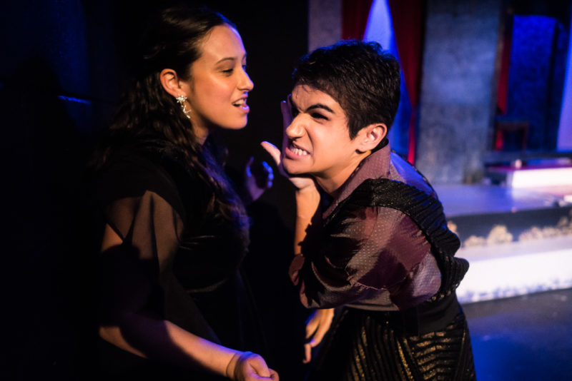
Figure 1. Kristen Alesia and Azkara Gilchrist in “Richard III” Babes with Blades Production 2022. Photo: Brave Lux
Figure 1 Image Description (ID): Two actors stand close together. The actor on the left has medium skin tone and long black hair. They look down gloating at the actor on the right, who grimaces angrily while holding her hand up to block her right side of her face. She has medium skin tone and short black hair.

Pity/Charity Cliché
Disability is reduced to being an object of pity in need of charity to survive.
One example of this is… The “Tiny Tim effect” from Charles Dickens’ "A Christmas Carol."
One way to combat this is… casting disabled actors. A 2019 production cast two disabled actors as Tim. This was celebrated by many, but did not address the power dynamics within the story. (Figure 2)
At NDT’s 2021 Holiday Salon, disabled artists from across the country discussed productions of "A Christmas Carol", writing an Open Letter to the industry, calling for theatres to commit to more respectful and responsible representations of disability for their annual productions.
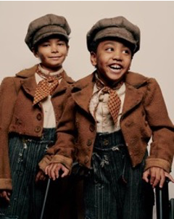
Figure 2. Jai Ram Srinivasan (left) and Sebastian Ortiz play the role of Tiny Tim in “A Christmas Carol” on Broadway. Photo: V. Tullo for The NY Times Nov 14, 2019.
Figure 2 Image Description (ID): Two boys, ages 8 and 7, stand in matching costumes side by side. They have medium-dark skin tone and are wearing brown jackets with a red plaid neckerchief, and grayish brown newsboy style caps. The boy on the right rests his hands on visible mobility aids.

Medical Cliché
Disability is an individual problem to be fixed or cured.
One example of this is…Tenessee Williams' “The Glass Menagerie.”
One way to combat this is… well, casting a disabled performer as Laura is a good start. (Figure 3)

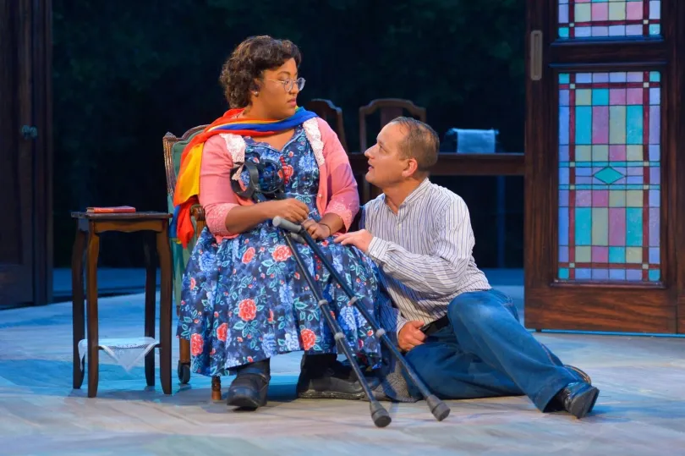
Figure 3. Phoebe Fico and Sean San José in CST’s “The Glass Menagerie.” Credit: CA Shakespeare Theater 2017.
Figure 3 Image Description (ID): A woman sits in a chair, looking down at a man sitting on the floor, gazing up at her. She has short, curly, dark brown hair, medium skin tone. She wears glasses, a blue dress with pink flowers, a sweater, and a scarf, and she holds her crutches in her lap. The man has light skin tone and short brown hair. He wears a white shirt and jeans.

Social View
Disability is situational; it is created by society's failure to support people who do not meet current societal norms.
Example: “Peeling” by Kaite O’Reilly explores aspects of identity as three characters reflect on their time in the chorus of “The Trojan Women.” (Figure 4)

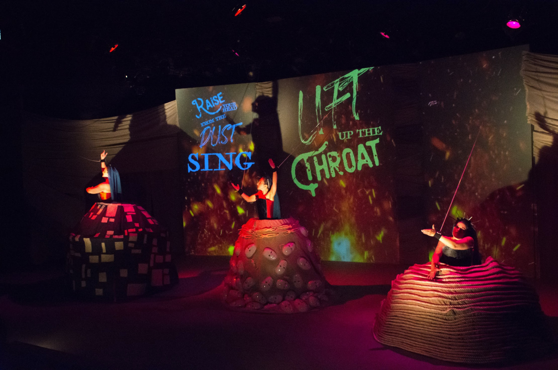
Figure 4. Carolyn Agee, Mary Schaefer, Sydney Maltese in “Peeling” by Kaite O’Reilly, Sound Theatre Company, 2019.
Figure 4 Image Description (ID): Three women with light skin tones are spaced across a dark stage. They are each inside a large ballroom skirt while their arms are connected to wires that control their wrists. The backdrop features projected captions displayed in colorful fonts that fit within the set design.

Cultural View (Disability Culture)
Disability is a form of cultural diversity with its own arts, languages, and customs.
Example: Phamaly Theatre Company, is based in Denver, CO. Their shows display a wide range of theatrical genres and styles, from classic plays to original works, told through a disabled lens by disabled artists. (Figures 5 and 6.)

Figure 5. Megan McGuire and Leonard Barrett in “Chicago”, Phamaly Theatre Company 2019.
Figure 5 ID: A white woman with short, curly blonde hair sitting beside a black man on a bench. She wears a blue and white polka dot dress, and she raises her arms up in the air, her left arm ending a few inches past her elbow. The man wears a blue-gray suit with a tie and sits with his hands in his lap. Both have joyful expressions.
Figure 6. “Fiddler on the Roof” at Phamaly Theatre Company, 2013.
Figure 6 ID: Two actors perform the bottle dance in Fiddler on the Roof. One dancer is seated in an electric wheelchair with a bottle on his hat, and the other actor stands balanced atop his chair with their body and bottle vertically above the first dancer’s bottle.

Cultural View (Disability Rights Lens)
Disability is a form of cultural diversity with its own arts, languages, customs, and rights.
Example: “Emily Driver’s Great Race Through Time and Space” by A.A. Brenner and Gregg Mozgala. This play for young audiences directly addresses disability rights and the systems that prevent disabled folks from getting the support we need to thrive. (Figure 7)
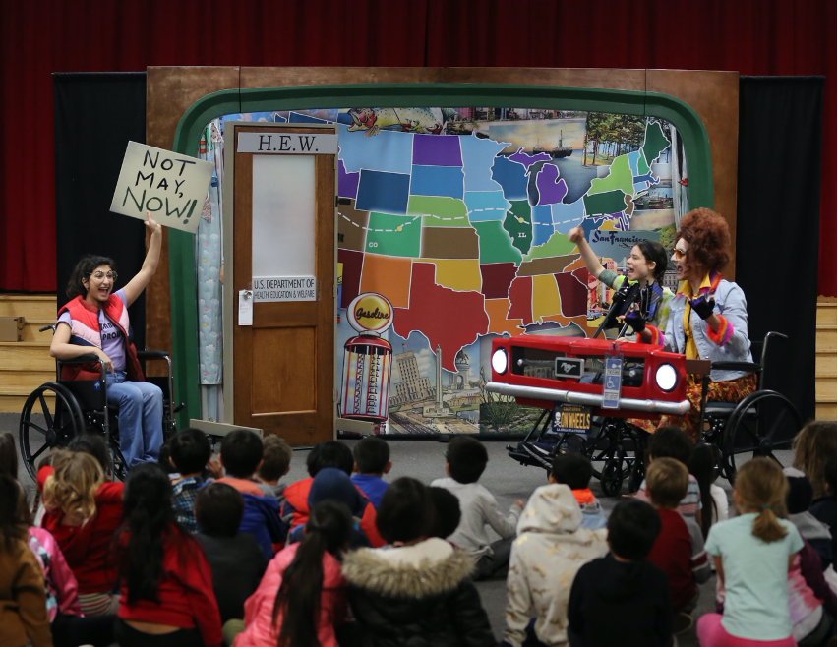
Figure 7. “Emily Driver’s Great Race Through Time and Space” by A.A. Brenner and Gregg Mozgala. LJP 2020.
Figure 7 Image Description (ID): Three actors in front of a map of the U.S., and a door with “H.E.W.” on top. An actor with brown skin and hair sits in a wheelchair, and holds a sign saying: “Not May, Now.” Two actors with white skin sit side-by-side wheelchairs with a red fender in front of them, and hold their fists in the air. Children sit on the floor in front of the stage area.

Intersectional View (Disability Justice)
Disability intersects with other forms of oppression, such as racism, sexism, homophobia, transphobia, and classism, and is shaped by broader social and political structures that perpetuate inequality and discrimination.
Sins Invalid is a California based disability arts collective founded by Patty Berne, Nomy Lamm, Leroy Moore, and other Black, Brown, Queer Disabled folks. Sins Invalid curated the 10 Principles of Disability Justice circa 2005.

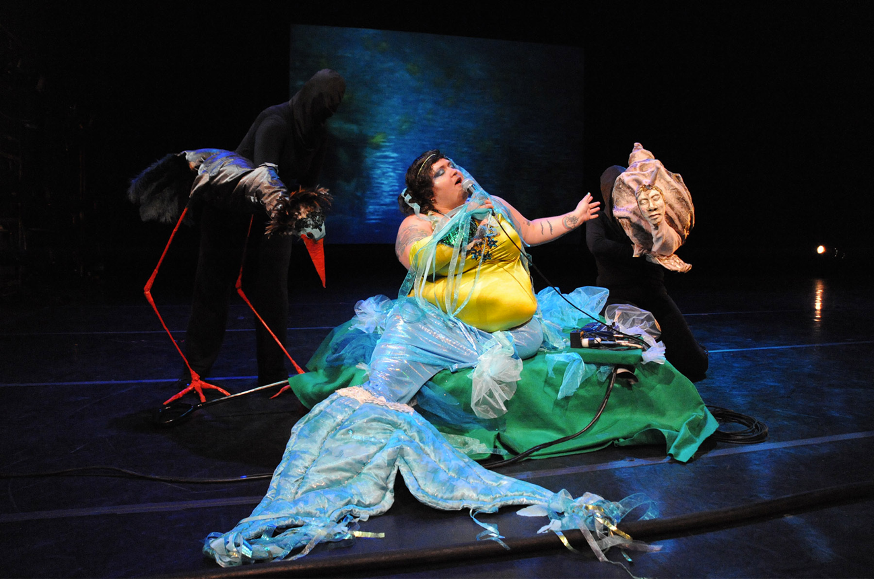
Figure 8. “We Love Like Barnacles” 2021: Nomy Lamm and Puppets, Sins Invalid.
Figure 8 Image Description (ID): A fat white Jewish femme dressed as a mermaid gestures toward a giant sea snail puppet with a human face. Behind them is a large black long-legged water bird puppet.

Potential for Erasure
The categories and examples in this section are just the tip of the iceberg. There’s a ton of Crip Art in a Disability Justice Aesthetic that has been, to date, under- documented or -recognized by mainstream culture.
For example, an online discussion in 2020 was hosted by Crushing Colonialism and Disability Visibility called Indigenous Spoonies Revolt. The event uplifted disabled and chronically ill Indigenous creatives like Frank Waln (Sicangu Lakota), Tony Enos (Cherokee), and Kera Sherwood-O'Regan (Kāi Tahu Māori). Artists shared their art, stories and discussed the intersectionality of their histories and struggles with erasure and recognition.
For more, the Appendix has a list of Disability-Justice Activists, Organizations and Coalitions.

A Handful of Tests and Lenses
There is no single test or checklist to ensure you are representing diverse experiences responsibly. The tests below are single tools, to be used as a part of a larger, holistic process. Individually, they establish a minimal but important baseline for representation.

The Bechdel Test
Many producing theatres may be familiar with the The Bechdel Test, named for celebrated cartoonist Alison Bechdel and originally created in conversation with Liz Wallace (2005). The Bechdel Test is one tool to measure the complexity of female characters presented in media: theatre, television, or film. It asks the following three questions relating to female representation:
- Does it have at least two women in it?
- Do the women talk to each other?
- And, if they talk to each other, do they talk about something other than a man?
The Bechdel Test is not a perfect measure of gender representation in media, and passing the test does not necessarily mean that a film or TV show is free of sexism or misogyny. However, it is a simple and useful tool for highlighting the lack of female representation in media and encouraging creators to include more well-rounded characters and storylines.

The Fries Test
Similarly, creative writing Professor Kenny Fries, in collaboration with Sherri Smith, curated what is now known as The Fries Test for storylines that include disability (2017). The Fries test asks questions to interrogate dominant narratives of disability representation:
- Does it have more than one disabled character?
- Do the disabled characters have their own narrative purpose other than the education and profit of a nondisabled character?
- Is the character’s disability not eradicated either by curing or killing?
Fries’ third question, sometimes referred to as a “better dead than disabled” storyline is particularly harmful, yet still prevalent with mainstream TV and Film narratives.

Other “Lenses” and Considerations
Ready to dig a bit deeper? Perhaps you are familiar with intersectionality, a term coined in 1989 by scholar Kimberlé Crenshaw. It describes the ways in which multiple identities intersect, and names the ways in which oppression compounds. Similarly, Disability Justice culture workers have explored how disability intersects with multiple identities and lived experiences.
Just one example is "Black Disability Politics", in which Sami Schalk discusses how incidents of disabling violence can be responsibly reported (2022, p. 73). The criteria are not directly related to storytelling on stage, yet they could be applicable in that context. For example, does a play with Black characters disabled by violence:
- Indicate that violence and neglect can cause some disability but that disability itself is not a problem?
- Emphasize the entwined nature of social justice issues like racism, capitalism, health care, etc?
- Demonstrate a need to support people disabled by oppressive structures and violence, whether or not they identify as disabled?
These criteria offer just one of many lenses to understand aspects of intersectionality and disability. Also, consider:
- D’Arcee Neal’s exploration of disability in Afrofuturism, called Afrophantasm
- Dom Evans’ work on disability representation, including his conversations with Anita Cameron, exploring the harmful comparison of “Blackface” and “Cripping Up”
- Nirmala Erevelles and Andrea Minear’s “Unspeakable Offenses: Untangling Race and Disability in Discourses of Intersectionality”
- Leah Lakshmi Piepzna-Samarasinha’s look at the power dynamics of care in “Care Work”, page 67
- Ronee Penoi’s essay, “Restorying Our Past and Present, Imagining Our Future,” on rewriting the dominant narratives that define us (2023)

Scene 2: Production Elements
Selecting existing scripts is only one way to support a Disabled- or Access-centered Aesthetic. You can also hire disabled producers, writers, designers, actors to create new disabled work. Claudia Alick of Calling Up Justice reflects, “The earlier you hire a disabled artist, the more access-centered the process will inevitably be.” This scene discusses hiring disabled artists, and offers strategies for creating access-centered auditions, rehearsals, and performances.

Hiring
In March 2023, the Inevitable Foundation released an open letter to the entertainment industry, asking them to hire disabled creatives in key roles, not as access consultants, noting that “authentic casting, a well-intended focus of the industry in recent years, is still not a replacement for having disabled talent in positions of power on a project” (Torelli-Pedevska, M. & Siegel, R.).
Hiring disabled artists–actors, writers, designers, stage managers, producers– is vital. Yet the disabled artists you hire may or may not be qualified to address representing disability responsibly. Disabled artists are at risk of telling stories using moral, charity, and medical clichés because we are surrounded by them. We are not immune. We live within the same racist, ableist, and oppressive structures as non disabled folks. Sometimes, we need support.
Yet when theatres don’t know how to offer support, disabled artists often become, by default, unpaid disability culture “experts” and access consultants. This additional emotional labor creates a power imbalance. NDT invited employers to consider:
- Investing in a staff member to lead ongoing access efforts for employees, artists, and audiences
- Hiring a production access coordinator and/or
- Compensating a consenting, qualified disabled artist specifically for their work as an access consultant
Within NDT, disabled artists had contrasting thoughts about the options above. Some artists wanted time and space to singularly focus on their artistic work, and welcomed outside support. Others felt additional compensation is a good fit for artists who have knowledge of access-centered strategies, and an interest in providing quality professional development.
For La Jolla Playhouse’s (LJP) 2020 POP Tour “Emily Driver’s Great Race Through Time and Space” By A.A. Brenner and Gregg Mozgala, NDT staff members consented in advance to use our time in two ways. We directed the show and consulted about access. Doing two jobs at the same time was not easy, but it solidified our commitment to a Disabled Aesthetic. It worked for us, but it may not work for everyone or every show.

Matching Actors and Roles
NDT was asked often about casting disability. The most frequently asked questions were, “Should a disabled role always be played by a disabled actor? With the same disability?” If you ask these questions to 10 disabled theatre artists, you are likely to get 10 different answers.
For NDT, our answer was always more questions:
- How does disability show up in the storytelling?
- What are the disability power dynamics in the story?
- Are disabled artists cast in any non disabled roles?
- How many other disabled artists are working on the show? As actors? Designers? Directors? Producers?

Authentic vs. Accurate Casting
While many disabled artists advocate for accurate casting, in which the actor and character share the same disabled identity, NDT encouraged theatres to think about authenticity in a broader way.
For example, in "Emily Driver's Great Race Through Time and Space", four actors played multiple disabled and non disabled characters. NDT cast two actors with apparent disabilities–one a single role whose lived experience matched that of their character. The other disabled actor played a character written without a specified disability. And, NDT cast two actors who voluntarily disclosed their disability identities as “it’s complicated.” They played many supporting roles, both disabled and non disabled.
Throughout the production, NDT relied on the lived experiences of the production team as a whole. For example, the cast included one part-time wheelchair user, but the artistic and design team had several disabled perspectives, including another part-time chair user. This diversified the group’s collective experience about how to represent disability in an authentic, though not entirely accurate way.
Theatre as an artistic discipline is not literal; it is playfully metaphorical. If the power imbalance of mainstream culture disability representation is proactively addressed, NDT believes disability can and should be represented by all different kinds of bodies and minds.

Disabled Designers
During the 2020 POP Tour, LJP worked with each disabled designer to identify and address their access needs. One commonality among multiple designers was the need to separate out the design process from the realization of that design. What do we mean by that?
Many training programs teach design by, in part, “crewing.” For example, you learn how to be a lighting designer by hanging lights and changing gels. You learn how to be a costume designer by stitching and sewing. Some of NDT’s designers' needs were met by contributing to the realization of their designs, others were not.
Sound Designer Evan Eason shared, “I originally wanted to be a lighting designer, but couldn’t do the ladders. Even now, there are times when my sound design changes if I can’t move a speaker to another location. Knowing from the start that LJP wanted me, all of me, and would be there to support my design was incredible.”
For all of the designers, LJP’s production team went beyond access services and co-created access support with each designer. By separating design from implementation when needed, LJP designs were realized on schedule with gusto. What a gift.

Auditions
Mainstream auditions require specific skills, many of which do not translate to the skills needed to perform in a play. In other words, auditioning is a separate skill from rehearsing, performing and contributing to an ensemble. Auditions often require the skills to manage:
- Material selection and memorization
- Micro time management (for example, a 2-3 min limit)
- Formal and informal social interactions
- Formal and informal information sharing
- A set, hierarchical power dynamic
What if auditions are not the starting point for casting? What if “audition” was re-structured? Re-defined?
That said, assuming your theatre still holds auditions in a traditional format, there are ways to make auditions more access-centered. In Fall of 2019, Actors Theatre of Louisville (ATL), alongside other Louisville-based theatres, hosted general access auditions, and specifically invited disabled artists to attend. While this was not an official NDT event, there was a huge crossover in practice. In planning access auditions, ATL removed many common barriers. Consider:

Material selection and memorization
Performers chose from a small menu of monologues or prepared either 1) an excerpt from an existing script, or 2) their own original material. Performers could come with their material memorized, or they could read it.

Micro time management
Auditions were scheduled in small groups of 10-15 minute slots. If a performer arrived either before or after their scheduled time, they joined the next group’s time slot.

Social interactions (formal and informal)
Each audition slot started with group introductions, in which everyone shared their names/pronouns and access needs. Performers chose if they wanted to do an individual introduction before their audition piece or not.

Information sharing (formal and informal)
Audition information was distributed in writing (via email and social media) and specific groups were directly invited to attend. The audition info included multiple ways to contact someone if there were questions, big or small. There was a person on-site to support form completion.

A set, hierarchical power dynamic
The energy in the room was supportive and relaxed. Everyone in the room got to know each other, asked questions, and tried things again. The goal went beyond casting and hiring to relationship and community building.
The Appendix has the full text of the Actors Theatre of Louisville Audition Information.

Variations, Evolutions, and Reflections
In May 2023, ATL held in-person local auditions with the following access supports:
- A single-slot (vs group) format with flex time
- A menu of material choices (either preparing a text/song or opting in to a mini-interview)
- Access service providers including an ASL interpreter
- Access Check-ins before, during, and after slots
Afterwards, ATL reflected that they could add the following to their next round of auditions:
- A group Meet & Greet in the space the day before
- A welcome guide (sometimes called a social narrative) with words and pictures that map out the environment of the audition, starting from when actors arrive, step by step until they leave
Every audition is its own variation, and will hopefully continue to shift and evolve over time.
For another example of Access-centered auditions, the Appendix has the full list of Phamaly Theatre Company’s Accommodation Recommendations.

Rehearsals
Many spoken and unspoken rules exist in “professional” rehearsal spaces. Consider:
- Actors should be fully memorized on the first day
- Breaks take place on a strict schedule
- Hours are long and sometimes very late at night
- Actors should remain still and quiet for long periods of “wait” time on and off stage
- Actors should use and sometimes move rehearsal props and furniture up until tech week
These expectations assume all actors share a uniform set of tools and training, and offer little flexibility and choice for some actors with disabilities.
Access-centered rehearsals are opportunities for learning. Like Access Check-ins, rehearsals can build community, vocabulary, norms. It is possible for rehearsals to flex and support the needs of artists (physical, intellectual, sensory needs, etc.). Companies like Phamaly Theatre establish their own rehearsal norms that create more accessible and sustainable practices– you can, too! The Appendix has the full list of Phamaly’s accommodations for rehearsals.
Currently, NDT is not aware of any theatres that use a production access coordinator, but we have not been shy about recommending it. We even wrote a job description!

Production Access Coordinator
Provide access support for cast/crew, which may include:
- Physical access support (can artists get in and out of the room? Are there usable restrooms?)
- Alternate formatting for text (Word, PDF, etc)
- Communication support (for info in advance, individual, or group communication)
- Transportation support (to/from rehearsals and performances; private or public.)
- Support Personal Care Advocates (meds, etc)
- Support Understudies (record and transfer info)
Document access notes on rehearsal reports for other departments, and may include:
- Physical placement of interpreters and caption signs
- Access to wheelchair seating and/or aisle seats
- Content-specific information like content warnings and sensory info like lights, sound, smells, etc.
- Contextual details for access service providers (audio describers or interpreters) to understand complex moments. For example, culturally–specific references, sound cues (for ASL interpreter prep), or movement sequences (for audio describer prep)

Performances
When theatres approached NDT for support making their performances more accessible for audience members, we invited folks to consider the ways in which they already support the four C’s– Collaboration, Communication, Choices, Creativity.
Below are two action steps that are starting points for audience access. Consider:

Focus Groups
Determine a specific community with whom you’d like to connect. Folks with physical disabilities? Folks who use ASL? Autistic adults? Children with autism and their families? Invite them to spend time with you and compensate them. If you don’t feel ready, hire a facilitator who has an existing relationship with the community. Then ask: Why do they come to your organization? Why not? What would make them feel welcome?

Frequently Asked Questions (FAQs)
Once you’ve convened a focus group, compile and share information. What questions might your audiences need answered to attend with confidence? NDT recommends an FAQ document that stays fluid and is easy to update.
Act 2 has more information on access planning. To learn more about how different regions coordinate access services, the Appendix has a list of cultural access consortiums. If your area is not listed, poke around, get a sense for how various communities navigate access services, and start planning!

Scene 3: Theatre in Educational Spaces
How drama and theatre are taught impacts many things: artist participation, skill building, training, and hiring. The hiring of disabled artists is directly connected to opportunities (or lack thereof) to teach and learn in formal and informal settings.
Scene 3 explores elements of teaching theatre, including Classes/Syllabi, and playing Theatre Games. For each element, we will start by summarizing how these elements might function in a traditional or mainstream way, and then offer ideas (some we tried at NDT, some we did not) for how to make each element more access-centered.
As you proceed, if it seems like the space between “tradition" and “access” is small–it is, and it is not. It’s been years of trial, error, discovery, and reflection. Evolving from disabled theatre students to a disabled theatre educators has meant facing many biases, including our own ableism and disableism, every time we teach.
For example, I (Talleri) have spent a lifetime navigating theatre spaces with a physical impairment. Thus, it takes focus and intention for me to teach students whose physical needs are met but use sensory or cognitive supports, for example. Working alongside disabled folks whose needs are different from my own is humbling and enlightening. Cross-disability solidarity is a practice.

Classes
In many traditional theatre training venues, artist/actor training can be both exclusive and harmful. Young artists can be expected to conform to an “ideal” body and/or mind. Furthermore, artists can be expected to ignore healthy boundaries, accept harassment, and exist in unhealthy power dynamics for the sake of “the industry.” But how can theatre training be inclusive, healthy, and supportive for both disabled and non disabled artists?
Officially, NDT had very few opportunities to train folks in higher education. Yet those of us who are educators have big thoughts on the matter. For example, we’ve observed that many theatre teachers (and theatres) desire to include disabled students as participants, especially when they are young. This kind of participation is vital, and, at the same time, baseline participation is not the same as providing young people with disabilities the chance to build skills as theatre artists.

Actor “Tools”
Many traditional theatre training programs expect artists to conform to a single standard of excellence/rigor, rather than centering the expertise of individual artist’s lived experiences, bodies, and minds. Consider these tools:
- Body–moving in specific, standardized ways
- Voice–speaking in specific, standardized ways
- Imagination–accepting a small bit of “pretend” as real
- Collaboration–being a “team player” in both healthy and unhealthy ways (see above)
What happens when actor training focuses on self-exploration and discovery, rather than conformity? People-centered training models support access. Many disabled folks are really excellent at self-knowledge and expertise because they’ve learned how to navigate a non disabled world. Disabled folks know about creativity, imagination, and innovation– we use them every day.
At the moment, NDT has few answers when it comes to formal training. We do have questions though. Consider:
- What do the details of disabled-led actor training look like?
- How can Actor Tools explorations harness crip wisdom rather than expect our bodies and minds to conform to non disabled standards?
- How can the language around (and understanding of) “training” our bodies and minds support ongoing self-exploration and self-knowledge?

AccessibleSyllabus.Com
If you’re designing a formal class, the access-centered concepts below could be applied within theatre and arts course outlines, starting in high school and beyond:
- Reasonable Expectations (clear rubrics in advance)
  - For example, offering many types of activities that show understanding vs one standard assignment. The Appendix has a sample menu for Character Creation assignments. (Reed College, 2018)
- Flexible Deadlines (choices vs one date)
  - For example, date ranges when folks can submit work
- Flexible and Creative policies for Attendance (options for participation)
  - For example, virtual, in person, synchronous, asynchronous ways to “attend” class
- Flexible and Creative “Late” Work policies
  - For example, can students submit work at any time for partial or full credit?
- Rhetoric and Policy (collaborative, not authoritative)
  - For example, co-constructing class rules
Access worker and educator, Alison Kopit, shares the following in her syllabi: "Please feel free to stretch, stand, use the bathroom, and move around as necessary, and I will do the same. Sitting [still] is not comfortable for everyone, but do be aware of your surroundings and respectful of other students’ space." This statement ensures all students understand what is expected (access, self-determination, care) and not expected (stillness, silence, assimilation).
In most university settings, the university’s access policy is copied/pasted into the syllabus. An additional, personalized statement of accessibility added to the required policy might make disabled students genuinely anticipated and desired in the space. Abolitionist educator Harper B. Keenan frames access like this: “If there is anything you need in order to make the classroom space or course content more accessible to you as a learner, let me know, regardless of any diagnosis or formally documented accommodations. If at any point you feel bored with, frustrated by, or disconnected from the course content, I’d like you to let me know so we can figure out how to make things better” (Keenan, 2022, p. 161-162).

Theatre Games
Whether teaching a class or leading a rehearsal, theatre games are often a cornerstone of building an ensemble and creating performance. While games are some students’ first experience of skill building, for many disabled students, they are the first barrier to contributing in a meaningful way. Whether or not they intend to, many theatre games:
- Can be demanding–physically, sensorily, or both
- Layer many skills (like movement, sensory processing, and response) at the same time
- Have an element of time pressure and/or competition
In addition, many classrooms and rehearsals have unspoken rules about how to play. Games “should:”
- Be played by everyone, at the same time
- Be played in a standing up circle
- Have a time boundary or ticking clock
- Be competitive or involve elimination
- Involve doing 2 or more things at once
- Require many “new” or “original” ideas
What if, instead games were played:
- Where some folks (not all) participate in each round?
- In short rounds of variations and translations?
- With each round focusing on one skill vs. multiple?
- With each round as optional instead of required?
- Sitting down, or in a combo of sitting and standing?
- With a menu of choices not an open-ended prompt?
- With elimination/competition as a brief, optional ending variation rather than a required component throughout?

Preparing for Access-Centered Theatre Games
When choosing a game to play with a specific group of people, consider the following questions:
- What is the goal of the game? (there can be many)
- What are the skills needed to play the game?
- Can the skills be done one at a time, not all together?
- Which elements (below) could work?
- Which elements (below) could change? Evolve?
- What variations are possible for this group?
- How could variations work together? Separately?

Elements of a Theatre Game
When planning variations and translations for theatre games, consider the following elements of engagement:
- Communication (could use sounds or movements)
- Physical Commitment
- Time Commitment
- Pace and Processing time
- Intensity
- Sensory Input
- Sensory Output
- Social Expectations
- Participant Roles
- Scaffolding
- (De)Layering or (Re)Juxtaposition of skills

Example One: Telephone
Telephone challenges participants to share a single phrase, with the goal of repeating the phrase to the next person exactly as it was passed to you. This activity can demonstrate how messages change when shared over time through multiple people. It can also serve as a representation of rumors, gossip, a circuit, or a catalyst.
Consider the variations for Telephone below, which can be played standing up, sitting down, in a line, or in a circle.
Variation A: Verbal Telephone
Listen to one sentence aurally and repeat it verbally as a whisper to the person in front of you.
Variation B: Tactile Telephone
Feel an image drawn on your back and gently draw the same image on the back of the person in front of you.
Variation C: Pass the Sound and Motion
Watch the person before you act out a sound, motion or both, and share it with the person in front of you.

Example Two: This is (Not) A Roll of Tape
This is a/Not a Roll of Tape asks students to use their imagination and pantomime skills to transform an object into something else. This activity supports students’ abilities to use specific details both in their pantomime skills and in their verbal description of an object. This activity encourages students to infer based on context clues, and identify the main idea of an action.
Variation A: This is NOT…
Stand or sit in a circle, and pass a roll of tape around the circle. When you get the roll of tape, hold it and say, “This is not a roll of tape, it is a [fill in the blank]” and act it out.
Variation B: This IS, and…
Sit or stand in a circle and pass a roll of tape around the circle. When you get the roll of tape, hold it and say, “This IS a roll of tape, AND it is [fill in the blank]” and act it out.
Variation C: Choose between two
Sit or stand in a circle and pass a roll of tape around the circle. When you get the roll of tape, choose between two things (for example, a donut or a bagel, a ring or a crown), then say “This is a roll of tape, AND it is [fill in your choice]” and act it out, showing the details of your choice.

Takeaway
If you’re truly engaging in multiple variations, not every person is going to participate fully in each variation. Not every person is going to feel successful every round. That is OK, and is a lovely lesson in itself.
After playing each variation, return to the questions you asked while planning: What worked? What could change?

Scene 4: Evolving from Early Covid-19
In 2020, as Covid-19 lockdowns took effect, dominant culture had a need that had to be filled. Thus, virtual communication strategies that disabled people have been using for years became standard for all. In the months that followed there was an undercurrent of evolution–for broader society, and for theatre makers. As an industry, we made some really, really cool stuff happen.
Now, three years later, the tools our industry embraced during early Covid are going away. Returning to “normal” excludes many disabled artists and audiences, and leaves us all under-prepared for future emergencies. Yet, when we keep Covid practices in use, we actively support an Disabled Aesthetic. Consider:

Hybrid Theatre
In 2020, 2021, and 2022, there was So. Much. Digital. Theatre. Hybrid experiences were, by design, more inclusive. There were choices: events could be attended either in person or online, participation could be verbal in real time, shared “in the chat” remotely, or even offered before or after an event took place. Now, in 2023, hybrid events continue to shrink.
Hybrid theatre is more access-centered than in person only. Yet just as theatres started feeling competent in making hybrid work, formal restrictions were lifted, and many theaters returned to an almost-entirely-in- person schedule. What if we, as an industry, continued to develop a hybrid storytelling aesthetic? What if we committed to serving artists and audiences to do their best work virtually and in person?
Disabled artist Terri Lynne Hudson proposes, “Every theatre should cast at least one virtual/remote artist in every production moving forward. Imagine what that would do for access, both logistically and artistically!”

Masks and Testing
In January 2023, Actors Theatre of Louisville (ATL) produced a workshop of “Ohio”, a concert by The Bengsons. The show wove together original songs and personal stories. One of many themes was hearing loss; the theatre tended to both practical and aesthetic access by hiring a live captioner for rehearsals and performances. The in-person venue was small.
During rehearsals, the Covid protocols included mandates for masks and regular testing for cast, crew, and guests. When it came time for performances, the artists were surprised that the public mask mandate had expired, and audiences would not be required to mask.
What followed were a series of meetings, listenings, and gentle access negotiations. ATL staff and “Ohio”’s artists came together many times to discuss masking needs, noting when needs conflicted. For example, masks create communication barriers for many with hearing loss. The results of their conversations were 1) a letter the theatre and artists co-wrote to audiences encouraging masking while acknowledging conflicting access needs and 2) steps taken by house staff to encourage masking on site when it did not present an additional barrier to audiences.
When audiences arrived, they were met by staff members wearing masks with clear windows by the mouth that could support lip reading. Audience members were reminded of the joint invitation to mask, and disposable masks were available at the entrance to the theatre. Throughout the run of the workshop (about three weeks), about 90% of audience members masked.
The Appendix has the full text for Actors Theatre of Louisville’s and the Bengson’s joint letter on masking.

Understudies, Callouts, and Cancellations
Before Covid-19, NDT encouraged hiring understudies who are ready to block, rehearse, or perform a role at any time. An understudy could be used for an entire rehearsal, or a 15-minute medication break. An understudy could learn the entire show, or be put in sparingly throughout the blocking process. An understudy can meet a host of access needs and make hiring disabled artists possible.
During “Emily Driver’s Great Race Through Time and Space” by A.A. Brenner and Gregg Mozgala, LJP supported the show using an understudy/ASM contract. Still, a handful of shows were canceled due to cast availability. At the time (pre-lockdown), the cancellations felt devastating. In hindsight, they felt necessary, human, and inevitable considering the demanding tour schedule. Life happens, and the show shouldn’t always go on.
Understudies for cast and crew, sick leave, and a system for callouts that can support the health and well-being of theatre workers was rarely seen in mainstream theatres before 2020. Yet they became fairly standard practice in 2021 and 2022. These policies don’t have to end with the end of formal Covid protocols. They can go on.

Covid, Intimacy, and Access Safety
For the last 1-2 years, theatres invested in Covid safety officers to support the health and safety of cast and crew. We’ve also seen a rise in the work of intimacy coordinators over the last 5-10 years making it clear the safer work conditions are a priority. Building on what we’ve learned by instituting Covid Safety Officers and Intimacy Directors into the production process, Production Access Coordinators could continue to make the rehearsals healthy, supportive spaces for all artists.
This is NDT’s dreamy-dream. It’s not implemented in the United States anywhere we know of yet, but still, we wrote a fantasy Production Access Coordinator job description.

Intermission: Culturally Specific Practices [fuschia]
Within disability, there are many communities, cultures, and even sub-cultures. NDT always recommends that theatres who are interested in a specific community work directly with the people within those communities. At the time of this writing, NDT leadership did not include Deaf or Neurodivergent artists. So in this intermission, we share the reflections of our colleagues at Deaf Spotlight and Spectrum Theatre Ensemble about Deaf Theatre, and Sensory-Friendly/Relaxed performances, respectively.
The Appendix has a list of more companies led by disabled artists, making disabled performance.

Deaf Theatre by Patty Liang of Deaf Spotlight
Theater is political. Theater educates. Theater fails. Theater connects a community together to share the experience together. Ephemeral. Theater provokes. Theater inspires. Theater compels. Theater is a litmus test of society. Theater can transform people’s lives, thoughts, and feelings.
To make your theatrical production a success, you MUST believe and practice this ethos internally within the self and overall organization: Everyone’s story matters. Their voices and lived experiences SHOULD be visible, recognized, celebrated, and honored on the stage. Each individual's multifaceted identity as a person matters. You cannot disregard or minimize different layers of each person's culture, language, race, sexual orientation, etc. You believe that underrecognized communities and their stories MUST be shared, acknowledged, and documented at all times and everywhere.

Deaf Spotlight
Deaf Spotlight (DS) mission is to inspire and showcase Deaf Culture and Sign Languages through the arts. DS was created out of necessity and a desire from the Seattle Deaf community to convene together at different events to enjoy the arts and culture.
DS is the only organization in Seattle, WA to offer performing arts/theatre featuring Deaf, DeafBlind, DeafDisabled, and Hard of Hearing (DDBDDHH) talent on stage in sign language.
DS cannot do these amazing productions without endless support from the board, volunteers, artists, contractors, funders, committees, and community like you over the years.
DS wants to see live theater with sign language integrated on stage so attendees can easily immerse themselves into the story without relying on interpreters.
Over the past 12 years, DS has produced three full-length productions and three short play festivals. We tried, adapted, and failed. We survived. DS is still learning and still wants to produce more theater where our community can be seen without any language and access barriers. DS believes that stories need to be seen, experienced, and accessed without any barriers.
Deafness is not a medical perspective that should be “cured.” “Deaf” represents a cultural linguistic community with a language and history.
DS wants to see more Deaf communities on the stage with different intersectional experiences.
Creating new and authentic narratives, breaking through tropes and stereotypes, that we are humans, with feelings with different paths of living.

Deaf-Led Theatres
There are only a handful of Deaf-led performing arts theaters. Theaters marked with an asterisk below are BIPOC-led.
- Connecticut Deaf Theatre (CDT) in Hartford, CT
- Deaf Austin Theatre (DAT) in Austin, TX
- Deaf West Theatre (DWT) in Los Angeles, CA
- Deaf Spotlight* in Seattle, WA
- Gallaudet University Theatre in Washington D.C.
- National Deaf Theatre (NDT) in Washington D.C.
- National Technical Institute of the Deaf (NTID) Theatre in Rochester, NY
- New York Deaf Theatre (NYDT) in New York City, NY
- Sunshine 2.0* in Rochester, NY
- ProTactile Theatre* in CO
- Urban Jazz Dance Company,* (UJDC) in Oakland, CA
- Visionaries of the Creative Arts* (VOCA) in Washington D.C.
The list above contains only five BIPOC Deaf-led theaters, including DS. Deaf theatre is sorely under-resourced, under-funded, etc. Consider investing in and championing performing arts led by people with disabilities, so their stories can be shared. Theatrical productions involve a lot of talent. Deaf Spotlight is committed to paying our cast and crews equitably and to provide opportunities of growth, experience, and networking.
In February 2023, disabled artist and National Disability Theatre advisory company member Ryan Haddad, in partnership with the Public Theater in New York City, produced Dark Disabled Stories incorporating captions, audio description, and American Sign Language (ASL) on the stage at the same time. It is revolutionary and we haven’t seen it like this on mainstage before.
Why is that? Why can’t we do the same thing, making ALL theater accessible for all audiences?

How to produce Deaf-centric theatre:
- Have a strong vision and belief that everyone’s stories matter and NEED to be celebrated
- Figure out access needs from the beginning, not as an afterthought
  - Access looks like: voice overs, rehearsal interpreters, captions, image descriptions, transcripts, ProTactile interpreters, ADA friendly spaces
- Build access needs into your budget
- Train and hire Deaf and disabled artists, administrators, and producers
- Mentor emerging Deaf and disabled artists, administrators, and producers
- Marketing and outreach
- Instill flexibility, compassion and grace
- Donate to Deaf-centric performing arts organizations
- Collaborate with artists and organizations that you haven’t before
- Make sure all aspects of your production are disability-friendly (building/venue, rehearsal, meetings, performances, ticketing, marketing, etc.)
Access is not a one-time thing. Your pursuit should be a lifetime effort. Even if you fail, keep trying your best to produce equitable and accessible theater within our community.

Example of Deaf Theatre
After the success of the first Seattle Deaf Film Festival in 2012, DS wanted to foray into different mediums like performing arts. We established the Deaf Spotlight Presents brand to create Deaf-centric theatrical productions.
Throughout the years, DS navigated different challenges such as budget constraints, accessibility funds, union costs, housing, a lack of local experienced Deaf actors, and the pandemic. With every production we steadily improved, even as we made mistakes and lost money. It was worth it to provide an accessible theatrical experience for our community.
Currently, DS produces theatrical productions in odd years, alternating with Seattle Deaf Film Festival in even years. We would love to produce theatrical events annually, but we need more time, money, people power, expertise, and energy to produce quality programming that is accessible for everyone.
For the first Deaf-centric production, our goal was to produce a script by a Deaf playwright, then to hire local Deaf actors and along with a Deaf director, with a signing backstage crew that used ASL / technical team. It was a big learning curve at DS because many of us were new to producing, mounting a full-length production and cobbling together a play from scratch.
In 2013, we produced Broken Spokes written by Willy Conley. The production was directed by Ryan Schlecht with a Deaf ensemble: Katie Roberts, Howie Seago, and Jeremy Quiroga. The performance run almost sold out, validating DS’ decision to produce theatrical events.
For the second theatrical production in 2015, DS was not able to find a script by a Deaf playwright and adapted God of Carnage, written by Yasmina Reza. It was translated to English by Christopher Hampton and translated by our team. Ryan Schlecht returned as director, joined by Deaf actors Anna Bracilano, Aimee Chou, Billy Seago, and Reggie Scott.
Next two years, DS decided to commission an original work by a local Deaf queer writer, Crystal L.M. Roberts, through the lens of Queer Deaf community. SKIN was born in 2019, under the direction of Alexandria Wailes and an ensemble of four Deaf womxn: Kalen Feeney, Amelia Hensley, Michelle Mary Schaefer, and Rhonda Cochran.
DS wanted to spotlight more artists and creatives, providing more work opportunities and growing their talent for future opportunities. However, we had only produced one full length production every other year. We felt that we need to build a creative equitable space for DDBDDHH to generate more original new stories and to share these on the stage without relying on scripts from non-Deaf writers. We provided affordable workshops with a Deaf instructor to teach playwriting in sign language to foster emerging playwrights.
From there, DS decided to produce the first biennial Short Play Festival featuring six short plays by Deaf playwrights (3 works from our playwriting workshop!). Under Kellie Martin’s festival leadership, DS hired three Deaf directors to direct two plays each, using a Deaf ensemble of several actors who would act at least twice in different plays. That way, each actor, director, and playwright could add the festival to their resumes leading to more opportunities to work with other theaters. We learned to pick a theme for the next time because it was difficult to incorporate six different genre sets in one festival!
For the second biennial Short Play Festival under Monique “MoMo” Holt’s leadership, the theme was “Bathroom Tales” along with a new festival tradition–offering an affordable playwriting workshop for emerging writers, leading up to the festival. The stories included everything from polluted water, mother-daughter rapport, sexual assault, and comedy, to murder. DS had to pivot to streaming due to COVID-19 pandemic. We had to figure out fast how to produce six separate plays in six different locations with six different teams. We learned that streaming made the festival more accessible than ever. Anyone in the world could watch our plays without any distance and financial barriers. It showed the importance of offering hybrid programming for major events like Seattle Deaf Film Festival and Short Play Festival. We will continue the hybrid model from now on.
The most recent Short Play Festival took place in March 2023 under Alexandria Wailes’ leadership, with the theme “Floral Shop.” The festival featured six original new works by Deaf and DeafBlind playwrights, six directors, and an ensemble of diverse actors from different backgrounds. In addition, DS used the radical hospitality model, inspired by Sound Theatre Company, a Seattle fellow theater and collaborator. We offered three ticketing options to ensure equitable ticketing experience for all. We also enforced a mask policy, ensuring health for our audience.
Our journey over the years has shown DS’s growth and the importance of adapting in order to continue producing Deaf-centric programming without compromising our beliefs, mission, and core values. We will continue to figure out how to bring authentic stories to audiences and to nurture these talented artists and creatives where they can continue their craft and bring their work to our stage one day.

Takeaway
This is not a one time thing. Your pursuit should be a lifetime effort with collaborators and artists. Try your best to produce equitable and accessible theater for your community. Keep creating authentic content and nurturing talent that you would go see on the stage for yourselves. If you do this, people will join and support your adventure.

Relaxed or Sensory-Friendly Theatre by Craven Poole of Spectrum Theatre Ensemble

Defining Neurodivergence
Neurodivergent, as framed by thought leader Kassiane Asasumasu, is an umbrella term to describe an individual whose mind or functioning diverges from dominant societal norms, standards or expectations including learning, processing, interpreting, feeling, behaving, communicating and more. Neurodivergence can be acquired or genetic, a fundamental part of your identity or not. Also, it can refer to a variety of conditions, including but not limited to:
- Autism spectrum disorder
- Attention-deficit hyperactivity disorder
- Dyslexia/Dyscalculia
- Epilepsy
- Obsessive-Compulsive Disorder
- Tourette's syndrome
- Down's syndrome
- Bipolar Disorder
- Various other developmental disabilities
- Brain injuries received during medical emergencies or
- Post-traumatic stress disorder (PTSD) from traumatic events
Regardless of the source of a divergent neurotype, ND bodyminds work differently. The way neurodivergent people make connections and interpret information diverges from the neuronormative framework, and can vary greatly between individuals and neurotypes.
Some relevant terms, definitions courtesy of educator Sonny Jane Wise:
Neuronormativity is a set of standards, expectations and norms that center certain ways of functioning as the superior and right way.
Neurotypical is a term to describe an individual whose functioning falls within those dominant societal norms. Neurotypical is the opposite of neurodivergent.
Neurodiversity (as theorized by Judy Singer) refers to the diversity of human minds and all the unique and different ways that people can exist, think, act, process, feel, and function. It is a fundamental truth that we are diverse in our minds just like we are diverse in our ethnicity, gender, sexuality, etc. A neurodiverse group includes both neurotypical and neurodivergent people

The Stigma of Neurodivergence
Many neurodivergent conditions are heavily stigmatized in modern society. There are many types of neurodivergence, and the perceptions and treatment of those people varies accordingly. However, they tend to share a high level of misunderstanding by the general public. If used thoughtfully, the arts can be an incredible tool to expand understanding and rectify misinformation. Unfortunately, media companies have not often succeeded in this. A good example would be how autistic people, and autism spectrum disorder, are represented.
Most stories, factual or fictional, focus on an extremely limited demographic. The diagnostic criteria most doctors use for autism are based solely on the study of white male children. Consequently, autism diagnosis rates are much lower among women, trans and gender-nonconforming people, and people of color. This doesn't mean that people in those demographics are less likely to be autistic, only that they're more likely to go without diagnosis or be incorrectly diagnosed with other disorders. Most autistic characters depicted on stage and screen perpetuate this stereotype. They also tend to focus on autistic characters with the highest level of support needs—those who require daily assistance to function—and position them as “low functioning.” Many autistic adults live full, independent lives with little additional support, and many more have rich lives because of the benefits of their interdependence.
Stereotyping and flattening of lived experience carries across all neurodivergences. Many neurodivergent people can be perceived as emotionally unstable, less intelligent, disruptive, rude, and more, regardless of their actual behavior, identity, and/or experiences. Neurodivergent people are moving through a world that is not built for them. If society fully accommodated their needs and desires many would no longer find the world disabling, which is one reason why many neurodivergent people do not identify as ‘disabled’—their bodymind isn’t the problem, their environment is. Others may not identify as ‘disabled’ because our society tends to silo and label those with different lived experiences such that it can be difficult to identify how our movements are linked. Additionally, the social model of disability has limitations, as some neurodivergent people find elements of their experience distressing and/or disabling regardless of accommodations and acceptance (though of course both remain important).

Neurodivergence and the Arts
Neurodivergence is not a deficit, and in fields like the performing arts neurodiversity—defined by Judy Singer as “the limitless variability of human nervous systems”—can be a benefit! Variety in lived experiences is part of what brings such value to our art-making. Yet many neurodivergent people face significant barriers to accessing the arts, both as audience members and as practitioners. For many ND people, especially autistic people, sensory overstimulation is a particular barrier. This manifests in various ways but can include:
- Lights are brighter
- Sounds are louder
- Textures cause greater reactions
- Smells are more intense
A theatrical performance with loud or sudden sounds, bright or flashing lights, and atmospheric effects could cause significant distress to an ND individual, impacting them both mentally and physically. Lights that wouldn't phase a neurotypical person might trigger severe headaches in a neurodivergent one. Sounds may trigger body aches or make one's skin crawl. Taking in a piece of art is impossible when its very form causes physical discomfort. A neurodivergent person may also struggle to process all the stimuli simultaneously, causing confusion, panic, and emotional distress—their nervous system becomes dysregulated. Yet theater is an incredible connection tool, and the neurodivergent people who want that connection deserve access.
Luckily, this barrier can be surmounted. Since levels and types of sensitivity vary from person to person, the accommodations they would need to participate also vary. Consider the following:
- Many ND people would find a regular, full performance doable with some simple sensory tools, like sunglasses or noise-dampening earphones. Such tools can be some of the most cost-effective ways to support attendance by ND community members, and are already frequently used by ND theater makers.
- Sensory overwhelm can be mitigated by breaks from the performance space—theaters could create an environment where ND people are explicitly free to enter and exit the space as they need.
- Theaters could provide an alternative entrance to the building so that ND individuals do not have to contend with crowds, or could offer them an escort who personally takes them to their seats.
- An alternative sensory-friendly space can be offered for ND individuals who need to calm their nervous systems. The specifics of the space would of course vary, but key elements usually include lower lights, less noise, clean and comfortable places to sit or lay down, space to move/stim, and physical items like fidgets for regulation.

Sensory-Friendly Performances
There are many additional accommodations a theater can make for its community members. The most substantial form of support would be to offer Sensory-Friendly performances, where technical elements are altered to be less overstimulating for neurodivergent audience members. These can include changes such as removing strobes, lowering sound cues, and lighting the audience differently. These alterations should be evaluated freshly with each new production; there is no one correct way to do it.
The first step should be to hire a sensory consultant— someone with lived experience who has practice in neurodivergence accommodations—to evaluate the physical theater space and its capabilities, as not all companies have the same technological resources or levels of access in their facilities. A sensory consultant could be involved in the first production meetings, where they would learn from the design team about the intentions for the performance and then work with the team to identify which technical elements could be adapted during sensory-friendly performances and what accommodations the theater can offer for the rest. Ideally the theater company's accessibility personnel would also be trained in how to perform this duty.
There also may be people within the performing arts organization who already have lived experience that could contribute to the mission of neurodivergent inclusivity and access. Many organization’s leaders do not realize they have ND staff because people may not be open about it due to stigma, a lack of support in their workplace, the feeling that it isn’t relevant to their work, or even not recognizing that their lived experience does in fact fall under the umbrella of neurodivergence. One of the key steps in making your performances accessible to neurodivergent people is ensuring that your workplace is too.
A common pitfall is: "My theater just doesn't have the resources to be accommodating." That is seldom true. The critical thing to remember is that even one accommodation is better than none. Every ND person experiences the world differently, so the accommodations they need can vary vastly. For some, sunglasses or noise-dampening earplugs may be sufficient. Others may require a dedicated sensory-friendly space in the building to which they can retreat when their nervous system is dysregulated. A playbill’s list of content advisories could include sensory stimuli as well, expanding on the advisories many theaters give regarding atmospherics or simulated gunshots.
These accommodations, and all others a consultant might suggest, can have wide-ranging benefits for audiences. There are infinite ways an audience member may want to experience the theater, and though these suggestions have an ND audience in mind, accommodations are available to anyone. Maybe someone had to have their pupils dilated at the optometrist that day—sunglasses would be perfect for them. Many people get headaches—earplugs can make the sounds tolerable. Say it's my first time visiting this particular theater—a person giving me a map and escorting me to my seat would go a long way. Particular lights, smells, and sounds can be just as triggering to some people as particular content, so a sensory advisory list would be invaluable for them. When a theater makes a true commitment to accessibility, everyone can participate. The most important thing is that the company listens and does what it can. Even one step is a step forward.

Altering Performances
A designer may feel resistant to altering their design for a sensory-friendly production, but there is one crucial thing to remember: neurodivergent community members want to see the intended vision. If the theater offers robust accommodations before the lights go down, the performance itself is much less likely to cause sensory overwhelm. How do these audience members get into the building? What sort of advisories do they get? What tools do you offer? How are the front-of-house staff trained? A neurodivergent person may respond to engaging theater differently than the average audience member. Perhaps they are so excited that they make noise or want to get up and pace. They are not intending to disrupt the experience for their fellow audience members, they are simply engaging fully with the art in the way most accessible (and often pleasurable!) for their bodymind.
Imagine this scenario: Alma is an autistic woman with medium support needs. She is independent, with disposable income, but her brain processes sound and light differently than her peers and she functions best with an aide. Alma loves theater and, if she could, she would love to attend productions put on by her local theater company. However, the first performance she attended was so overwhelming that it triggered a panic attack. It's a painful lesson: theater is just not accessible to her. Then, Alma learns that her local theater company has taken up a new accessibility initiative. They're offering the accommodations she would need to experience the full performance. Neurodivergence can often be incredibly isolating, but theater has the potential to open up entire worlds. That is what the artists intend when they create, and that is what the performing arts can do for someone who finds the world alienating. So Alma goes, and suddenly the impossible has become possible. She's the audience they want: engaged, enthusiastic, and loyal. This is only one scenario but thousands, tens of thousands, hundreds of thousands of Almas wish to participate.

Supporting Nuerodivergent Audiences and Artists
This is not an insignificant portion of the community. In 2021, the Centers for Disease Control and Prevention reported that 1 in 44 children is diagnosed with an autism spectrum disorder. As of April 2023, that statistic has been updated for accuracy to 1 in 36 children (CDC, 2023). As stated earlier, that percentage only addresses the children who manage to get diagnosed. It doesn't account for those diagnosed in adulthood or who never receive an accurate diagnosis. And as discussed initially, neurodivergence is an umbrella term: it is currently estimated that 15-20% of the population is neurodivergent in some way. Those numbers will likely increase in the years to come as our society builds a greater understanding of the intersections between neurotype, gender, race, class, and culture. The performing arts are poised to be one of the most moving, effective tools in the struggle for true equity and accessibility. All humans, regardless of neurotype, love stories, and everyone has the right to experience the stories that theater artists tell. This sort of participation also encourages neurodivergent community members to become active in the arts themselves, to add their own stories to the growing cultural dialogue, and it creates space for current neurodivergent arts workers to exist more fully and authentically in their field. Given how historically lacking ND representation has been in the arts, the theater community must work together to allow ND people to represent themselves.
It does not have to be all at once, nor does it have to be everything listed here—and it’s important to remember that this section is just an introduction to neurodivergent inclusion. The main roadblock is assuming your company doesn't have the ability, but the best accessibility programs are grown thoughtfully over time. True equity cannot be a "someday" goal; the audience is here now, ready to buy a ticket and share the experience. When they get that ticket scanned and walk through the door, let’s be there to meet them.
Craven Poole
Resident Dramaturg
Spectrum Theatre Ensemble
For more information about our Neurodiverse Inclusive Certified Entertainment (NICE) program or to set up a consultation with Spectrum Theatre Ensemble, please visit our website at www.stensemble.org or email us at info@stensemble.org

Act 4: Variations on Reflections [green]
Act 4 is a reflection on what National Disability Theatre did and didn’t do in its five years of existence. We explore how we succeeded, “failed,” and did both at the same time. While NDT was often externally called upon to advise other companies, internally we were constantly trying out new processes and testing new variations to meet the shifting needs of our own organization. At times it felt chaotic, at times it felt hypocritical, many times it felt thrilling. Below we offer a kaleidoscope of variations of reflection:

Scene 1: Successes and Stories of Pride

We Made a Show! (January 2020)
La Jolla Playhouse’s (LJP) Performance Outreach Program (POP) Tour is an annual production that brings live theatre to San Diego area schools. Ideally, audiences are students in grades 3 – 6. Each year, the POP Tour is an original, world-premiere commission. It features 4 actors and runs 40-45 minutes. In 2019-20, NDT and LJP developed and co-presented “Emily Driver’s Great Race Through Time and Space” with a team of disabled writers, directors, and designers.
The story: 12-year-old Emily Driver uses her YouTube channel to celebrate moments of activism and change. When her request for a needed wheelchair is denied, she time-travels across the country where she meets trailblazing leaders from the past who have fought for equal rights. Co-written by A.A. Brenner and Gregg Mozgala, “Emily Driver’s Great Race Through Time and Space” follows a young woman's journey as she learns the power of speaking up, and how one voice can help others to fight the forces of ableism and create a more just world. The play can be found on the New Play Exchange.
The show’s design included audio description, a sensory-friendly environment, and selected captions interwoven into the world of the play. Scenically, the script called for a vintage mustang to be onstage for most of the show. Unlike wheelchair Halloween costumes that transform wheelchairs into other things, NDT was looking for a design that highlighted the architecture of the wheelchair. With a smile, D/deaf scenic designer Sean said, “You’re looking for a design that is Wheelchair Gain.”
Sean reflected, "This [was] the first time I was allowed to be me and the entire design team understood all the wonderful benefits that me being Deaf contributed to my ability to design visuals." Indeed, it was the first time many of us had been in the same room with each other. While not being the only disabled person in a room was a welcome breath of fresh air, it also brought new tensions to negotiate. We considered:
- Who was the “expert” on disability?
- How do we acknowledge that we each have our own relationship with disability, and not police others?
- How do we meet our collective, not only individual access needs?
- Whose needs get priority, especially when meeting one access need creates a barrier for someone else?
- How do we disagree?
- How do we get ANYTHING done on a non disabled (pre-pandemic) production calendar?
It wasn’t easy. Relationships began, grew, strained. Unexpected access needs came up. Things shifted. We laughed a lot. We had wonderfully awkward dance parties. Schedules changed. A lot. Things got canceled. But we did it. We made a show!
The Appendix has pictures and image descriptions of rehearsal and performance of LJP’s 2020 Pop Tour and a letter of support from Sequoia Elementary School.

Anti-Racism Intensive (2019; Fall 2020)
To address NDT's strategic plan recommendations, NDT scheduled an Anti-Racism Intensive with The Harriet Tubman Collective in 2019. It was planned as an in-person gathering of four people: Mickey, Talleri, Dustin Gibson, and TL Lewis. Then, many things shifted: Global lockdown; People all over the country protested police brutality; An artistic leader performed white fragility on social media; Artists resigned from NDT; Plans between NDT and The Harriet Tubman Collective rightfully changed due to Dustin and TL’s urgent work with carceral systems.
With all that in mind, in Fall 2020, the intensive shifted to a virtual platform. NDT Advisory Company members, whom we had only met virtually a couple of times, were invited to participate. In total, seven participants from NDT (plus Dustin and TL) gathered for over 20 hours. All of us identified as disabled; two participants identified as People of Color, and five participants identified as white.
For some of us, it was the first time we defined disability in community. For some of us, racism and disablism were part of our lived experience—one participant shared that they had been talking publicly about the intersections of race and disability for decades. For many of us who were disabled and white, it was one of the first times we discussed issues of racism in a disability-centric space rather than a non disabled space.
Dustin and TL illuminated how race, class disability, and power structures interact within organizations. For example, the hashtag #DisabilityTooWhite by Vilissa Thompson highlights many ways in which racism can show up in white-led disability advocacy spaces. Disabled artist Terri Lynne Hudson reflects, "White crips sure are loud. And when they are problematic, they use disability as a shield to dismiss their problematic behavior." These ideas contextualized the past, and planted seeds for future discussions– about harm, accountability, and the tools NDT did and did not have as an organization.
We brainstormed how NDT might intentionally build anti-racist structures. In the weeks and months that followed, NDT created working groups to decentralize NDT’s decision-making processes. We left hungry for more—more time, tools , and chances to connect.

Work groups (2021)
After NDT’s Anti-Racism intensive, NDT decided to decentralize organizational decision-making using work groups. Work groups consisted of 3-6 people with a variety of lived experiences: diverse disabled, cultural, racial, gender, and artistic identities, as well as age, class, and citizenship. One rule was, “if the group doesn’t disagree with each other, it isn’t big enough.” This intended to counter the one-person consultant model and replace it with collaboration and community.

Accounting for Social Justice (2022)
NDT paid disabled people for their work. Yet, many financial systems in society work against disabled people. For example, some disabled artists face income limits connected with Social Security Insurance (SSI), or, depend on non-banked support. NDT staff worked hard to compensate artists lots of ways:
- Direct and Indirect payment
- Individual payment schedules including health and caregiver stipends
- Resource/skill exchanges
- Non-monetary compensation

Consent-based practices for Social Media (2022)
In 2022, NDT began regularly featuring disabled artists on social media. NDT’s social media manager, working with staff, created a consent-based communication process:
- NDT posted a call for nominations on social media
- Names and contact info were submitted to NDT
- NDT compiled names/contact info in a spreadsheet
- NDT contacted artists to:
  - Inform them of their nomination
  - Invite them to submit a picture, image description and bio for sharing (Note: Part of the process was artists describing themselves!)
  - Let them know their post was up!

Scene 2: Binaries, Spectrums, Tensions
During its tenure, NDT navigated many productive tensions. As theatre artists, we knew tension was/is key to storytelling on stage– without it, ideas that stretch from one extreme to another don’t stay connected. In the moment, NDT’s tensions did not feel like useful connectors that brought together seemingly opposite binaries into a helpful spectrum. We didn’t always find a balance in the middle of two extremes; we jumped from one end to another. For example, NDT wanted to be:
- Supportive and Challenging
- Mainstream and Experimental
- Professional and Scrappy
- Stable and Innovative
- Respected and Rebellious
- Confident and Vulnerable
- Independent and Interdependent
- Able to adapt and Able to impose
- Able to assimilate and Able to transform
- Safe and Risky
- Understanding and Accountable
- Flexible and Structured
- Reliable (full time) and Flexible (part time, gig)
- At times, everything to everyone!
Over weeks, months, and years, NDT had interesting, engaging conversations about these false binaries. We discussed how to acknowledge them, work within them, transform them. The conversations themselves were important, and often challenging to translate into action.

Scene 3: Beautiful “Failures”
Over the last five years, NDT grew. Fast. We were an idea. Then we were a website. Then we were an organization. Then we had a multi-project partnership. Then we made a play. Then the globe had a pandemic. Then people left. Then we got to know new people. Then we had new staff. There was so much learning and so many “failures.”
"Care Work", page 65, lays out some of the possible pitfalls when dreaming about care webs. Consider:
- Pitfall: Crips supporting crips! Only! Ever!
- Pitfall: Assuming that we intrinsically understand other’s access needs; access intimacy is given
- Pitfall: Not paying attention to the gendered/raced/classed dynamics of care
- Pitfall: Doing all the admin work yourself
- Pitfall: Assuming there is one right way, and that a way that works for a while won’t change
- Pitfall: Assuming someone else is the “expert”
Oh, did these resonate with NDT! With the pitfalls above in mind, consider NDT’s “failures” below:
- People agreeing and participating with and w/out shared understanding
- People disagreeing with and w/out tools for repair
- People joining and leaving NDT at various speeds with and w/out clear expectations
- Leadership unsure of what to “do”
- Audiences unsure of what NDT was “doing”
- Shifting access needs that changed expectations
- Inconsistent internal communication
- Inconsistent external communication
- Inconsistent engagement of stakeholders
- Unclear leadership responsibilities/ power dynamics
- Unclear protocol for personal and professional communication and accountability
- Fragility around and Fear Of Missing Out (FOMO) on opportunities as a “national leader”
- Fragility/FOMO about excluding people when our mission is radical inclusivity
- Fragility/FOMO around expectations of what a non-profit organization can and can’t do
- Balancing multiple and seemingly contradictory lived experiences and perspectives
"Care Work" offers this reflection: “I wish we could've known that the struggles we had weren't failures or signs of how inadequate we were but incredibly valuable learnings. I wish I had known then what I do now… that we were by far not the only disabled queers to struggle with them and that our struggle to figure out these questions is at the heart of our movement work” (2021).
In hindsight, NDT’s beautiful “failures” were, like the ones shared in "Care Work"–common, inevitable, humbling, and tools for learning and growth.

We back to me; beyond the 1st Edition
Talleri here. These successes, stories of pride, tensions, binaries, “failures,” learnings, and are all part of NDT– one big, wonderful, messy, paradox . In the future, there may be even more wisdom to glean from the lists, the sections, the stories, shared above. Even though NDT is no longer in operation, I hope the ideas in this Handbook will grow, and will evolve. In that way, perhaps this will not be an ending; it also will be a beginning.

Curtain Call: Resources Snapshot [fuschia]

NDT Handbook Appendix
NDT Timeline and Values 143
NDT: La Jolla Playhouse’s POP Tour 2020 147
NDT: A Christmas Carol Letter Spring 2022 156
NDT’s Resources Webpage (draft in progress) 160
Actors Theatre of Louisville: General Accessible Audition (Fall 2019) 167
Actors Theatre of Louisville: A Note About Masking, January 2023 171
Phamaly Theatre Company’s Accommodation Recommendations: Working with Performing Artists with Disabilities– Denver, CO 173
Phamaly Theatre Company’s Audience Agreements (2021) 182
UDL Sample Lesson Outline 184
Assignments for Character Creation, Thea 203: Acting Lab (Reed College, 2018, E. Leffler) 186
More Photos 194
Further Resources 198
Consulting/Services 198
Additional Viewings 198
Additional Readings 198
Works Cited 201

NDT Timeline and Values

Phase One (2018-2020)
History
In fall of 2018, National Disability Theatre (NDT) was founded by Mickey Rowe and Talleri McRae as a thought experiment, a “what if.” What if there was an organization that was not tied to one geographic location or community? What if that organization could partner with theatres across the country to make their work more access-centered, use a disabled aesthetic, and hire more disabled artists?
In 2019, secured its first funder, hired a strategic planner, Annette de Soto with Beyond the Divide, and landed its first multi-project partnership. Mickey and Talleri served as artists in residence for La Jolla Playhouse’s 2019-2020 season and as team members for the 2020 Performance Outreach Program, "Emily Driver's Great Race Through Time and Space" by AA Brenner and Gregg Mozgala, which opened in January. In March, the show shut down due to Covid-19.
Values
At its founding, NDT utilized a disability rights-based framework. Its mission was “to employ professional artists who create fully accessible, world-class theatre and storytelling; change social policy and the nation’s narrative about disability culture; and provide a guiding model in accessibility for the arts and cultural sector.”
Through NDT’s strategic planning interviews, NDT knew, learned, and re-learned that the experience of disability occurs alongside other identities, and that disabled people who are Black, Brown, Trans, Queer, Indigenous, gender non-conforming, or non-binary have been historically marginalized within the mainstream disability rights movement. Thus, we catalyzed efforts to reach beyond a single-issue disability rights lens and strive towards the multi-issue principles of Disability Justice.

Phase Two (2020-2021)
History
In late Spring 2020, more than one NDT-affiliated artist resigned following personal online interactions involving racism and white disabled activism. With the support of Annette de Soto from Beyond the Divide Consulting, Advisory Company, and Board Members, NDT stayed focused on its strategic planning goals from 2019. NDT continued work with Disability Justice practitioners like Dustin Gibson, Talila Lewis, and Claudia Alick to learn about anti-racism in disability-led spaces and how to support radical inclusion at every level of NDT.
In 2021, NDT partnered with Sound Theatre Company (STC) and Calling Up Justice to curate a 30-day online learning series that looked at the intersections of Racial and Disabled Justice. The series was shared on social media and featured in two virtual conversations:
- Theatre at the Crossroads: Racial & Disabled Justice
- Deaf in BIPOC Spaces (with Deaf Spotlight)
Values
NDT’s strategic planning that began in 2019 was documented in early Spring 2020. It referenced the wisdom of Disability Justice activists like Mia Mingus and KiTay Davidson, NDT organized its strategic plan by the values of Interdependence, Innovation, Flexibility (Crip Time), and Mutual/Collective Liberation.

Phase Three (2021-2023)
History
In 2021, NDT implemented multiple community-based work groups to select its first Managing Director, Penny Pun. NDT developed administrative structures, codified consulting practices, and planned programming. We partnered with organizations like The Pearlman Arts Center and La Jolla Playhouse to support disability-centric work in a sustainable way. NDT hosted two gatherings:
- "A Christmas Carol" Holiday Salon, Dec 2021
- Pod-Mapping with Blasian March, March 2022
In January 2023, NDT announced its intention to “sunset” as a 501c3 organization in order to separate its work from the not-for-profit structure. NDT’s “approach” of supporting access-centered theatres will live on.
Values
In 2022, NDT grounded our consulting in the following concepts: Art as Access/Access As Art, Sustainable, Community-Centered, and Economically Just.

NDT: La Jolla Playhouse’s POP Tour 2020

Artistic Team
Playwrights: A.A. Brenner and Gregg Mozgala
Co-Directors: Talleri McRae and Mickey Rowe
Scenic Designer: Sean Fanning
Costume Designer: Mallory Kay Nelson
Stage Manager: Chandra Anthenill
Assistant Stage Manager: Evelyn Myers

Photo: Development Workshop (Fall 2019)
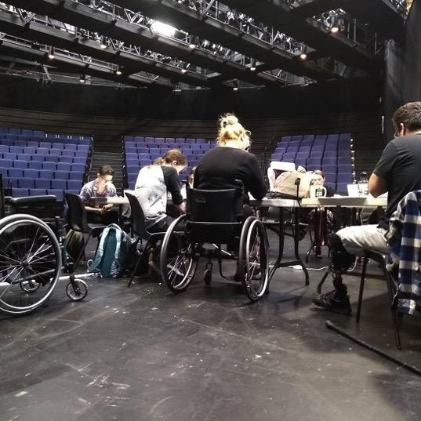
Figure 9. Development workshop of “Emily Driver’s Great Race Through Time and Space” by A.A. Brenner and Gregg Mozgala. La Jolla Playhouse.
Figure 9 Image Description (ID): Four people sit around a table, the backs of their heads are down. On the right is a black wheelchair, then the two most visible people: in the middle is a person with light skin and blond hair sitting in a wheelchair, and on the left is a person with brown hair and medium brown skin and a prosthetic leg.

Photo: Rehearsal Wheelchairs with “Headlights”
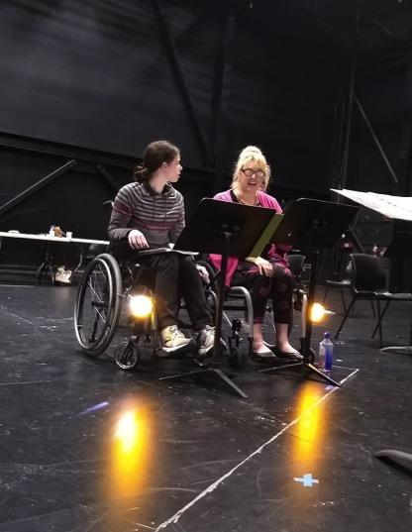
Figure 10. Development workshop of "Emily Driver's Great Race Through Time and Space" by A.A. Brenner and Gregg Mozgala. La Jolla Playhouse.
Figure 10 Image Description: Two actors with light skin sit in wheelchairs side by side on a black stage, back wall, and music stands in front. On the outside of each wheelchair, just above the footrest, are flashlights that resemble headlights. Yellow lights reflect on a black floor.

Photo: Cast Members
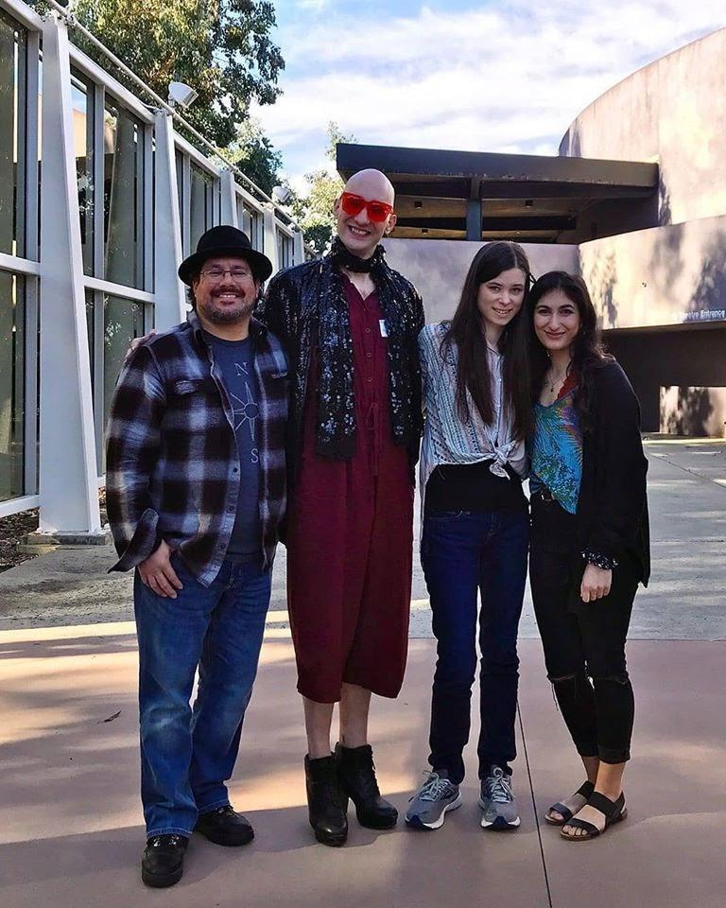
Figure 11. Emily Driver's Great Race Through Time and Space, the cast: From L to R, Paúl Arujo, Jaye Wilson, Cass Pfann, Farah Dinga. Photo courtesy of LJP.
Figure 11 Image Description: Four actors standing outside of a theatre on a sunny day. From left to right, one is a Latinx man with a goatee wearing black and grey plaid shirt and black hat, the next is a tall, white, non-binary individual wearing a plum colored romper, a leather jacket, high heels, and and bright orange glasses, the next young white woman with brown hair, jeans, a button up tied in a knot in front. The last is a middle eastern woman with long brown hair, sandals and a turquoise colored top.
Photo: Double Wheelchair Car
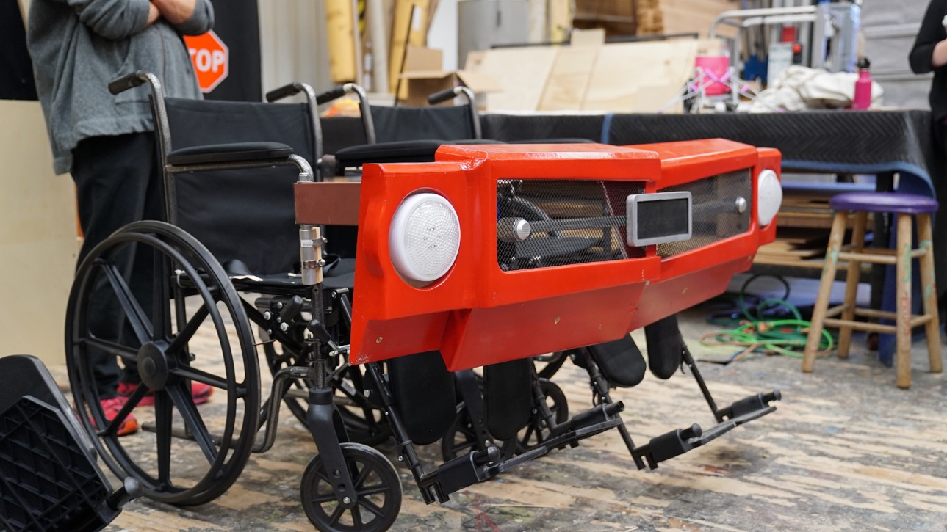
Figure 12. "Emily Driver's Great Race Through Time and Space" by A.A. Brenner and Gregg Mozgala Photo courtesy of La Jolla Playhouse. Scenic: Sean Fanning
Figure 12 Image Description (ID): Two black wheelchairs with footrests, side-by-side, in profile. Across the front of the chairs is a red fender with white headlights and a mesh metal grill in the middle.

Letter of Support from Sequoia Elementary School, January 2020
San Diego Unified School District
Sequoia Elementary School
4690 Limerick Avenue
San Diego, CA 92117-3220
Phone 858.496.8240; Fax 858.496.8329
Wednesday, January 29, 2020
La Jolla Playhouse,
On behalf of all the students at Sequoia Elementary School, I would like to share my gratitude for visiting our school each year to perform the first POP Tour performance in the San Diego Unified School District. This partnership has been one of the most rewarding experiences we've had since its inception a few years back. Since our school is a VAPA school now, it's incredible to experience a play performed up close with extremely talented actors. It really gives our students something to aspire to in the future. Furthermore, each and every year, there is a great message for our students to learn from each performance.
This year, that message was extremely powerful. We were lucky enough to watch “Emily Driver's Great Race Through Time and Space.” There were so many things that the students took away from this show, but the main theme was very clear - You have to make your voice heard when you see an injustice or in this case, someone is being denied access to the same opportunities afforded to other people. Furthermore, the students were able to learn about the history of seclusion and how brave men and women made their voices heard to bring about the historic ADA legislation. The La Jolla Playhouse was able to bring this message to us in a way that was extremely entertaining and also very inspiring.
In fact, this year the message was amplified because our school didn't have access for people in wheelchairs. I know San Diego Unified School District shares my view and the view of Sequoia Elementary, that everyone should be fully included in all endeavors. So, that's why I'm proud to say that our district responded quickly to this situation and has a plan to take care of the problem. I believe we have turned this event into an impactful learning experience for our students. This play was intended to teach kids to take action when they see a problem and we did just that! There was a problem at Sequoia and now something positive has come from that issue. In conclusion, thank you to La Jolla Playhouse, National Disability Theater and to all involved in this important production. You made the world a better place at Sequoia!
Sincerely,
Ryan Kissel
Principal Sequoia Elementary

NDT: A Christmas Carol Letter Spring 2022
May 31, 2022
To Whom It May Concern:
We are National Disability Theatre, a growing collective of disabled artists and non-disabled allies across the country. National Disability Theatre (NDT) 1. employs professional theatre artists; 2. creates fully accessible, world-class theatre and storytelling; 3. changes social policy and the nation’s narrative about disability culture; and 4. provides a guiding model in accessibility for the arts and cultural sector. We understand that your organization is producing "A Christmas Carol" in 2022.
As you may know, while people with disabilities make up between 20-25% of the population, authentic representations of disability are rare. All too often, disabled characters like Tiny Tim evoke judgment, charity, or pity. This misrepresentation directly impacts employment for disabled artists, especially those who are Black, Indigenous, Mixed, and/or People of Color. In December 2021, NDT invited disabled artists and non-disabled allies to explore "A Christmas Carol"–its themes, its history, and how it is performed. Many productions feature racially diverse casts, and a handful include a single disabled performer; yet most do not fully embrace disabled artists with intersectional lived experiences in their storytelling.
As an organization that produces "A Christmas Carol", we call you to action to hire (even double cast!) multiple adult disabled actors in your 2022 production and beyond. Now more than ever, we need to disrupt familiar narratives to understand how the oppressive social structures around us impact the intersections of race, class, gender, age, and disability. Imagine what an ensemble of disabled Black, Brown, and/or Queer artists alongside Tim would change. "A Christmas Carol" with a disabled lens is a concrete step towards authentically representing disability and understanding disability culture.
NDT’s network can support your logistical and artistic needs. NDT can offer your organization the tools to:
- explore your organization’s relationship to disability, access, and equity
- structure your organizational resources to support hiring disabled artists
- plan for access-centered/equitable auditions, rehearsals, and performances
- craft your audition notices with access-centered/equitable language
- connect with local, regional, and national networks of disabled actors
- hire disabled directors, designers, dramaturgs, stage managers, dialect coaches, composers, access service providers, and craftspeople (especially when it’s time for a "A Christmas Carol" redesign!)
- seek disabled playwrights to write adaptations of "A Christmas Carol", and other titles as well
- consider other “seasonal” titles that authentically represent disability
- expand audience support like captioning and “relaxed’ expectations
Whether you are interested in hiring NDT in a consultancy, or partnering for a full-fledged production in 2022 or beyond, please don’t hesitate to contact us. We would be honored to work alongside you.
Signed,
Penny Pun (she/her) New York, NY and Talleri McRae (she/her) Louisville, KY
Co-signed,
Cassandra Brown (she/her) New York NY, Christine Bruno (she/her) New York, NY, Sofiya Cheyenne (she/her) Long Island, NY, Richard Costes (He/him) Chicago, IL, Annette de Soto (she/her) Seattle, WA, Terri Lynne Hudson (she/her) Chicago IL, Elbert Joseph, E.J. (They/them/he) Boston, MA, Diana Elizabeth Jordan (she/her) Los Angeles, CA, Sarah Kenny (she/her) New York, NY, Andrea Kovich (she/her) Seattle, WA, Regan Linton, she/her/hers, Washington DC, Clay Martin (he/him/his) Providence, RI, Ben Raanan (he/him/his) Denver, CO, Peter Royston (he/they) New York, NY (Manahatta) , Lisa Sniderman/Aoede (she/her) San Francisco, CA, Emily Tarquin (they/them) Louisville, KY, Teresa Thuman (she/her) Seattle WA, Danny Woodburn (he/him) Los Angeles, CA

NDT’s Resources Webpage (draft in progress)
NDT’s resource page, designed to be shared on its website, was intended to be an open-source resource for resources that support disability-centric performance work, as well as general organizing resources that support Disability Justice and Disability Rights frameworks. While NDT’s website is not able to host this nomination-based resource page, we wanted to share it with you anyways!

Disabled Performance: A Sampling
There is a wide variety of work being done within the category of “disabled performance.” Therefore, NDT uses the following priorities in sharing nominated resources. All nominated organizations and individuals will be notified before being listed publicly.
NDT prioritizes work that is:
- Disability-led in a Disability Justice Framework
- Disability-led in a Disability Rights Framework
- Disability work within a POC-led organization
- Disability work within a PWI-led organization
- Disability work by disabled artists who are Black, Brown, Queer, Indigenous, or otherwise multiply marginalized
- Disability work by disabled artists
Below is a sampling of artists, activists, and organizations creating disability-centered and disability-led theatre, dance, music, and more art across the nation!
A.B.L.E. Ensemble (Chicago, IL)
Apothetae (New York, NY)
Art Spark Texas (Austin, TX)
AXIS Dance Company (Berkeley, CA)
Bodies of Work (Chicago, IL)
CARPA San Diego (San Diego, CA)
CO/LAB Theater Group (New York, NY)
Curb Appeal Gallery (Chicago, IL)
Dancing Wheels Company (Cleveland, OH)
Deaf Broadway (New York, NY)
Deaf West Theatre (Los Angeles)
Detour Company Theatre (Phoenix, AZ)
Encore! Studio for the Performing Arts (Madison, WI)
Full Radius Dance (Atlanta, GA)
Hollow Organ (New York, NY)
InterAct Theatre (Minneapolis, MN)
The Gift Theatre (Chicago IL)
Kinetic Light (New York, NY)
Krip-Hop Institute (Los Angeles, CA)
Open Circle Theatre (Washington DC)
Phamaly Theatre Company (Denver, CO)
Press Here Studio (Chicago, IL)
Queens Theatre (New York, NY)
Rotations (Online)
Sins Invalid (Bay Area, CA)
Sound Theatre Company (Seattle, WA)
Spectrum Theatre Ensemble (Providence, RI)
Tellin’ Tales Theatre (Chicago, IL)
Theatre Breaking Through Barriers (New York, NY)
The Curiosity Paradox (Portland, OR)
Unfolding Disability Futures (Chicago, IL)
Urban Jazz Dance Company (San Francisco, CA)

Access-Centered Event Planning
Part of National Disability Theatre’s mission is to be a resource for accessibility in the arts and cultural sector. Below are tools for access-centered event planning:
1) HEARD community organizing guide
This resource serves as a guide for community organizers/educators on how to build virtual learning communities that are grounded in the principles of disability justice and language justice because the revolution must be accessible!
ASL Resource: bit.ly/accessrevolutionASL
English Resource: bit.ly/accessrevolution
Spanish Resource: bit.ly/revolucionacceso
Text ONLY English & Spanish with image descriptions: bit.ly/accessrevolutionTXT
2) Sins Invalid Access Suggestions for Public Events
This document lives on their
3) Creative Access article on Howlround
This article reflected on a Theatre Communications Group session in 2017 that was a collaboration with Talleri McRae, Regan Linton and Monique Holt.
4) Disability Justice: An Audit Tool – PDF here
5) Accessible Virtual Programming Toolkit

Disability Justice Activism Organizations, Coalitions, and Collectives
Part of National Disability Theatre’s mission is to advocate changes in social policy. Disability Justice is a specific framework of 10 principles that engage intersectional justice-based moment work that centers the experiences of disabled people who are Black, Brown, Queer, Indigenous, and/or multiply marginalized. The individuals and organizations below operate in alignment with the principles of Disability Justice:
Access-Centered Movement
Andraea LaVant of Andraea LaVant Consulting
Autistic Women of Color and Non-Binary Network
Christiana ObeySumner of Epiphanies of Equity
Claudia Alick of CallingUp Justice
Disability Justice Collective (Detroit)
Disability Justice Culture Club
Dustin Gibson of People’s Hub
Embraced Body
Harriet Tubman Collective (Contact Dustin Gibson or TL Lewis to connect with HTC)
Jen Deerinwater of Crushing Colonialism
Leah Laksmi Piepzna-Samarsinha
Mia Mingus
Sins Invalid (Bay Area, CA)
Tiffany Hammond of Fidgets and Fries
Vilissa S. Thompson of Ramp Your Voice
TL Lewis of HEARD

Cultural Access Consortiums
Part of National Disability Theatre’s mission is to be a model for accessibility in the arts and cultural sector. Cultural Access Consortiums are geographically-based resources for cultural arts providers to learn, share and support each other in providing access services to as many disabled audiences and artists as possible.
The Leadership Exchange in Arts and Disability– LEAD (national, hosted by the Office of Accessibility/VSA at the John F. Kennedy Center for the Performing Arts)
All-Access Inclusion Network (Formerly Inclusion Network of Nashville, TN)
Art of Access Alliance (Denver, CO)
Arts Learning Community for Universal Access (Raleigh, NC)
Cultural Access Collaborative (Formerly Chicago Cultural Access Consortium, Chicago, IL)
Cultural Access Network Project (New Jersey)
DC Arts & Access Network (Washington DC)
Florida Access Coalition for the Arts (Miami Metro, FL)
Metro Regional Arts Council (St. Paul, MN)
Michigan Alliance for Cultural Accessibility
MindsEye’s Arts and Culture Accessibility Cooperative (St. Louis, MO)
Minnesota Access Alliance
Museum, Arts and Culture Access Consortium (NYC)
Seattle Cultural Accessibility Consortium (Seattle, WA)

Actors Theatre of Louisville: General Accessible Audition (Fall 2019)
A collective of local Louisville theatre companies is excited to announce two days of general auditions open to all Kentuckiana area residents with the specific intention of inviting and providing accommodations for performers with disabilities of all ages.
The auditions are being facilitated by theatres [aaa], [bbb] and [ccc]. Theatres that will have casting representatives in attendance at the auditions are [aaa], [bbb], [ccc], [ddd], and [eee].
Auditions are available on two different days at two different locations.
The first day of auditions will be [date] from [time] at located at [place], in the 5th floor rehearsal studios which are wheelchair accessible by small elevator.
The second day of auditions will be [date] from [time] at [place] in the [room] located on the first floor, which is wheelchair accessible.
All actors are asked to attend auditions with the materials they feel most comfortable with. This could include but is not limited to:
- a one- to two-minute memorized monologue
- a “cold” (meaning unprepared and given to actor upon their arrival) or prepared reading from a scene in Actors Theatre’s "A Christmas Carol"with a reader provided for you
- Singing a verse of either a musical theatre or classical piece, either acapella or with accompaniment you provide
- Playing a song on an instrument on which you have proficiency
- Presenting any combination of these pieces or something entirely different!
Our priority in these auditions is to create and maintain an environment of mutual trust where people are treated with dignity and respect. We seek an environment that is absent of intimidation, oppression, and harassment and upholds Actors Theatre’s core values of Equity, Diversity, and Inclusion; Brave Curiosity; Listening and Sharing; and Adaptability. With our Anti-Harassment Policy, Actors Theatre will prevent and correct inappropriate behavior, and we ask all involved to uphold these policies and join us in this work. We are committed to the most inclusive representation of race/ethnicity, gender, body type, age, and ability on our stages.
We welcome performers of all abilities and will make reasonable accommodations in order to audition and cast performers, regardless of disability, in any role possible.
There are several ways to request an audition. You may email [zzz] at [z@abc], Call and leave a message at their work number [1234], or text [5678]. We ask that when you request an audition, you provide us with the following:
- Your full name, and if you are under 18, your guardian’s full name and contact information
- Your phone number
- Your email address
- Your preferred method of communication: text, phone call, or email
- Your preferred audition date and location
- Your preferred time slot for an audition. Please request auditions in one hour increments (for example: 3:00 PM to 4:00 PM). Auditions can be up to 15 minutes in length
- What material you are planning to audition with (you are free to change later)
- Any questions you have about the audition, as well as any specific accommodations we can provide you before or during the audition appointment to make your experience positive. Examples include but are not limited to Braille or large type audition materials, wheelchair accessibility (and if it is an electric wheelchair), help with form completion, an audition greeter, pre-audition space orientation, ASL interpretation, etc.
In order to provide for specific accommodations, please notify us of your desire to audition as soon as possible. Please allow up to four days to reply to your request.
If you have any general questions about what an audition might be like, what material you might want to prepare, or what to expect at an audition, you can email [ttt] at [t@xyz], or text [1234]. Please begin your text or email with your full name and why you are reaching out, and allow 2-3 days for them to reply.
Finally, we encourage all to spread the word about these auditions. If you know of any students, friends, or colleagues with disabilities of any age that would like this specific opportunity, please share this with them and encourage them to sign up!

Actors Theatre of Louisville: A Note About Masking, January 2023
While Actors Theatre of Louisville has released our masking mandate for audiences, for our current production of “Ohio”, we are inviting you to mask for the best possible protection of the artists and their family.
A note from The Bengsons about masking: We know that wearing a mask is a bummer - trust us, we are also sick of the mask and the mouth smell and the trouble hearing one another. But, we are a high-risk family with a young child below vaccination age and aging parents who live with us. Our family is taking some risks to support us traveling to Louisville to perform (the only time we’re in public unmasked!). We love them for that and we invite you to join us in caring for them by masking with us as we welcome you into our 'home' for “Ohio.”
While masking makes this workshop possible, we know it also creates barriers. For some – including many people who experience hearing loss – masking can get in the way of speaking, hearing, lip reading, and other forms of communication. This is why the performers unmask to perform and the theatre's Radical Hospitality Team is experimenting with masks that have clear windows to make communicating with a mask as effective as possible; we are learning as we go.
There are, of course, many other benefits and barriers of masking we haven't addressed, and everyone's needs are different. Above all, know we want you to feel "at home" while you are with us, and that we're providing an environment to the best of our resources where you can assure your needs are met. “Ohio” will be a mask-affirmative, non-judgmental space where we can all work together to meet each other's individual and communal needs -- with no questions asked.
Thank you for being part of our extraordinary community of care here in Louisville.
We can't wait to be with you,
Abigail, Shaun, the “Ohio” Team, and Actors Theatre of Louisville

Phamaly Theatre Company’s Accommodation Recommendations: Working with Performing Artists with Disabilities– Denver, CO
www.phamaly.org
This list of accommodation recommendations is very attainable – most of them require little more than forethought and, maybe, a volunteer. This list is intended as a general guideline for theaters to implement to make their processes more accessible. Many of these accessibility tools can also be implemented in school settings or other work environments.
MOST IMPORTANTLY: When involving artists with disabilities on specific projects, communicate directly with the performer about his/her/their specific accommodation needs.

General
- Accessibility Contact: Ensure that your organization has a primary contact who can handle questions or requests about access and accommodations. Make sure the contact is listed clearly on your website and other materials so it is easy to find!
- Think Access and Design with Equity: Start including Access as a topic you discuss in relation to all aspects of your organization and production planning process: programs, hiring/casting, culture, marketing, production selection and design, budgeting, etc.
- Do a Self Assessment on Access: Consider different aspects of your organization/school. How accessible is the space? Are there accessible bathrooms? Do you have a list of resources for ASL interpreters, Braille translators, audio describers, and Directors of American Sign Language (DASL)? What kind of sensory environment do you have? Do you have a practice of actively welcoming and assisting those with disabilities? Consider bringing in an experienced accessibility consultant who lives with a disability to provide feedback.

Auditions
- Accommodations Contact: Ensure that advertised audition information includes contact information (phone and email) for a specific contact who can answer questions about access and arrange accommodations.
- ASL Interpreters: Provide ASL interpreters as an option for individuals at auditions. Make sure you have a list of interpreters you can contact prior to auditions. Ask the auditioner if they have a preference on who interprets. List the option for ASL interpretation on all audition materials.
- Social Stories: Provide a social story (pictures included) to prepare individuals living on the autism spectrum or with other social sensitivities with information about pathways to an audition location, the people they will meet inside, and the general experience. Preferably, have this available on your website and available to email on request.
- Form Completion: Provide a volunteer who can assist individuals in filling out and reading forms at the audition location; provide online forms that can be completed on a computer and submitted electronically or downloaded and printed before the audition.
- Audition Prep: Provide opportunities for group or 1-on-1 audition prep so that auditioners can get answers about material selection, audition techniques, and other foundational skills, or about the process of the audition (particularly for those who may be unfamiliar).
- Acoustic Checks: Allow the performers access to the audition room in advance, and/or allow the performer to work with the accompanist to ensure the performer can hear appropriately before beginning.
- Quiet Rooms: Provide performers a safe and calm space where they can decompress or remove themselves from the melee of the audition lobby.
- Physical Access: Provide facilities and rooms that are accessible to any individual with a physical disability – including restrooms with accessible stalls and easy access from the waiting area.
- Supportive Atmosphere and Additional Time: Understand that the experience of auditioning can be more overwhelming than usual for individuals with disabilities due to a variety of factors (access challenges they encountered on the way, social sensitivities, anxiety, the pressure of being the only person with a disability at the audition, etc.) Experiences of disenfranchisement and devaluation can often follow a performer into the room, and they will feel pressured to not only deliver a good audition, but to also justify their existence and belonging in the space. Consider providing extra time for direction, a second audition delivery, or a simple conversation to relax the room. This not only helps the individual deliver a successful audition, but also creates an opportunity for the performer to electively share information about themselves and their experiences that will be helpful in casting.

Callbacks
In addition to those listed above:
- Accessible Sides/Readings: Provide Braille, large print, and/or electronic scripts – as well as lyrics and music – for individuals who may need them. *This will require arranging Braille transcribers in advance. If you have an individual with an embosser, sometimes they can turn small projects around (i.e. sides) quickly.
- Additional Time for Cold Readings: Allow additional time for individuals who may need a few extra minutes to prepare for cold readings, including people with visual impairment, dyslexia, or other situations.
- Readers: For individuals who have difficulty with impromptu memorization/script familiarity during cold readings, provide a reader who can gently provide prompts alongside the actor during the reading.

Rehearsals
In addition to those listed above:
- Info Sheet: Have ALL participants complete an info sheet that allows them to identify any ways in which staff/instructors can assist them to be successful in the required activities (particularly things they may not feel immediately comfortable sharing face-to-face). Possible info to inquire about: do they need more time during breaks for bathrooming? Might they need a chair during long periods of scenework? Do they need a quiet room? What else should you know to make them successful?
- Orientations: Provide a pre-rehearsal gathering for cast members with social sensitivities or other needs so they have a chance to experience the rehearsal room before it's crowded with cast and crew.
- Accessible Scripts/Recordings: Provide Braille, large print, electronic, and voice-recorded scripts – as well as lyrics and music – for individuals who may need them.
- DASL: If you engage actors who use ASL on a production, ensure you have a Director of American Sign Language (DASL) to appropriately translate aspects of the written script into ASL.
- Readers/Notetakers: Provide individuals who may need assistance with learning lines, writing blocking, etc. with a volunteer who can assist them during the rehearsal process. *Ensure that you provide enough time for all performers to write down blocking in the moment and clarify any questions about direction, particularly if an intermediary such as ASL interpreter is being used, which may slightly delay communication of the direction being given.
- Extended Breaks: Provide ample time (10-15 minutes) for individuals to use the restroom, access water, etc., particularly if there are unique access challenges at the facility (i.e. taking an elevator to get to the accessible restroom).
- Scheduling: Provide individuals a rehearsal process that promotes physical well-being and self care, such as a five-day rehearsal week with reasonable time frames. Provide individuals with potential advance schedules bi-weekly so they can plan accordingly for accessible transportation, rest time, medical appointments, etc.
- In-Room Support: In addition to Stage Management (or part of the SM team), designate someone that can assist performers with medication timing, dietary needs, service dogs, etc.
- Rehearsal Recordings: Provide audio or visual recordings of music, dance, or staging rehearsals, and allow performers to record on their own.
- Bad Day Accommodations: Provide “plan-b” staging and rehearsal options for days when performers may have additional pain or movement difficulties.

Performances
In addition to those listed above:
- ASL interpreters: Provide interpreters so that performers who need them ALWAYS have a way to communicate and receive information quickly and effectively.
- Cues: Provide visual or auditory cues for entrances, bows, etc. as needed.
- Onstage/Backstage Assistance: Provide actors with peer support as needed to navigate onstage/backstage environments.
- Costume Modification: Provide adaptive accommodations for unique body needs, including Velcro rather than snaps, costumes that don’t have to wrap underneath a body (for folks who are sitting), holders for pacemakers, colostomy bags, etc, extra costuming for wheelchairs, canes, crutches, and other adaptive devices, or any other unique modification that might be necessary.
- Dressing room support: Provide a volunteer that can help performers backstage with individual needs, including changing costumes, monitoring medication and dietary needs, transporting props, etc.
- Accessible Technologies: In-ear monitors, video monitors, cue lights, and other accessible technologies to allow performers additional support.
For more information, please feel free to contact Phamaly Theatre Company – info@phamaly.org, 303-365-0005

Phamaly Theatre Company’s Audience Agreements (2021)

Experiencing a show at Phamaly
Phamaly prides itself on being a national leader in accessibility and inclusion. These values, which we hold so dear, are not limited to our artists onstage but extend to those in our audiences. The traditional mold of a theatrical event was not created with differences in mind, therefore we reject many of these unspoken rules. We aspire to create a space for you to experience this show in whatever way best serves your needs.
In this artistic space:
- No one is allowed to curate your emotional response to the performance. Feel free to laugh, cry, or sigh at any moment…even if you are the only one doing it.
- Your accessibility needs, no matter what they may be, are both valid and vital.
- Differences should not be put on a hierarchy. All disabilities, whether they be visible or invisible, are welcome here. There is no such thing as being “more disabled” or “less disabled.”
- The experiences you carry with you are the lifeblood of the theatrical process. Please don’t shut them out. Embrace them.
- No matter who you are, this theatrical event belongs to you. This community belongs to you. You are welcome. You belong.

UDL Sample Lesson Outline
The lesson outline below is adapted from a playwriting class at the KY School for the Blind. (Actors Theatre of Louisville Playwright Discovery Contract with VSA/The Office of Accessibility at the John F. Kennedy Center for the Performing Arts, and Arts for All KY). Topics include Setting, Character, Conflict, Structure, and Revision.
Engagement: Question of the Day
- The question varies by topic each day
- For example: If you could be anyone else for one day, who would you be and why? (character day)
- Answers can be verbal or written, shared during or after class
Representation:
- Teaching Artist shares daily topic in many modalities
- For example: bringing a set model to touch (setting); bringing costumes to try on (character); acting out beginning, middle, and end (structure)
Expression
- Students create original work based on a prompt
- For example: listening to different kinds of music, then creating a setting for each one; creating a character profile of wants, needs, and obstacles.
- Students can write independently, write with a scribe, verbally describe their ideas, or choose from a menu of options if communicating by AAC

Assignments for Character Creation, Thea 203: Acting Lab (Reed College, 2018, E. Leffler)
Actors do lots of different kinds of work to bring their characters to life on stage. In this class, we will focus on six: (1) constructing a detailed biography of the character, (2) answering Stanislavsky’s “six fundamental questions” about a character, (3) improvising moments from the character’s history, (4) conducting life studies, (5) embodying “metaphors” for the character [animals, objects, and natural forces], and (6) embodying the music of a character.
In the next few weeks, you will do extended work with at least two of these six methods for the character you’ve been assigned. You can of course work with all six if you want to maximize your growth as an actor, but the expectation is to do extensive work with at least two of these methods and to prepare to take 10-15 minutes of class time to share what you’re doing on each assignment.
In this packet, you’ll find detailed descriptions of all six of these assignments.
Please read the packet carefully this weekend, and please choose two of these assignments that you’ll be doing for this unit. By Sunday, Feb 4, at 7 pm, email me to tell me which you’ll be doing. On Monday, Feb 5, I’ll come to class with a schedule for the next two weeks that includes who should be prepared to share their work on which day.
All books referenced in this packet can be found on reserve in the Performing Arts Resource Center (PARC).

Assignment #1: Character Biography
Imagine the significant events in the life of this character that have shaped him/her/them. This may look very different from person to person, depending on the play, the character, and the actor. Engage with the vivid, juicy details that really matter to your character. These events should all be informed by the play, but you can also include information that the playwright doesn’t provide. The task here is to flesh out the character’s backstory, discovering/inventing a history that is informed by the basic information the playwright has provided.
To do this most effectively, first read the chapter “Transference” from Uta Hagen’s A Challenge for the Actor. This chapter will inform your biography.
Character biographies are expected to be 4-8 pages (double spaced). They do not necessarily need to account for the whole arc of their lives; in some cases, it may be better to dwell on a particular incident in their past for the majority of the assignment.
If you choose to do this assignment, you will end up sharing part of your biography in class with peers, so that they can respond to it by helping you flesh it out further.

Assignment #2: The “Six Fundamental Questions”
Stanislavsky proposed that there were six fundamental questions for actors to ask about their characters, and Bella Merlin explains the questions very clearly in her book, The Complete Stanislavsky Toolkit. The questions challenge you to take stock of what information the playwright has given you about the character and the world in which they live; the questions further challenge you to develop some creative ideas, rooted in the text, about what animates them. To answer the six questions, you’ll need to read the play carefully, do a little outside research about the social/political world in which it is set, and think creatively about what might motivate a human being to do the kinds of things your character does.
For this assignment, you’ll need to first read pp. 100-112 in Bella Merlin’s The Complete Stanislavsky Toolkit. This assignment should be 6-12 pages, double-spaced (averaging approx. 1-2 pages per question).
Just like Assignment #1, students who do Assignment #2 will end up sharing part of their written document in class with peers.

Assignment #4: Moments from a History- Improvisation
The challenge of this assignment is to assume the identity of your character and play out some of the activities and confrontations that have shaped them. These are the same types of improvisations we’ve been doing in class as we work to play one another. Some of these improvisations may capture activities that the character has done habitually, over many years. Some may be things that happened once but that have fundamentally shaped the character. On pages 187-190 of his book, David Downs writes explicitly about the kinds of improvisations he would set up for actors working on Who’s Afraid of Virginia Woolf?. None of you are working on this play, but these are still useful models for thinking about what kinds of improvisations to set up for yourselves.
If you choose this assignment, you’ll work independently (at home, or signing out the rehearsal room) to try out many of these improvisations. You should do this in a physical, embodied way, even though you may need to imagine/visualize some of the other characters. I expect you to take about 1-1.5 hours of rehearsal time doing this, and then bring in 2-3 such improvisations to do in front of the class.
This assignment can be productively coupled with the biography assignment, or the two assignments can be done independently of one another.

Assignment #4: Life Studies
When actors conduct life studies, they find real people who seem to manifest some of the qualities that we find in our characters, and they study those people. If you choose this assignment, you’ll do this with your character. Where will you look in Portland to find a contemporary manifestation of this character? Go to that place where you think you will find him/her/them. Find someone whom you think it will be worthwhile to observe. Unobtrusively watch them. Take note of the details. What does this person’s spine do? How does it resist gravity? What do their eyes do? What do they reveal about the way this person has learned to engage with the world? What do their hands do? Take note of all the interesting details you see. If you’re not able to watch that individual for very long, then do so for as long as you can, and then find somebody else to observe. Spend about 30-45 min in observation.
Then go home and find a spot alone to embody what you saw. This step is crucial. “Try on” the body that you observed. Don’t make assumptions about the psychology of the person until you feel out their physiology. Live in their bodily architecture for a while. Then, from within, take note about what insights you come to about that person. Spend about 30-45 minutes doing this second part of the assignment. (If you don’t have a good space in your home or dorm to do this work, sign out the rehearsal room. That’s what it is here for.)
When you share your work in class, you’ll try to recreate this again, with all of us watching. You’ll “try on” the body publicly that you’ve already tried on at home by yourself. As you do so, you’ll describe for us what you’re experiencing and what you’re learning from that.

Assignment #5: Metaphors
Using pp. 148-162 of David Downs’s book and Chapters 9-11 of Moni Yakim’s book as a guide, figure out what animals, natural forces, and objects might be useful to embody in order to orient yourself to the rhythms and dynamics of your character. Use the text of the play as your guide, and then do that physical, embodied work on your own (at home, or signing out the rehearsal room as a workspace). Once you embody the mouse, the storm, or the knife that you think is the essence of your character, then embody the humanoid version of that metaphor which brings you closer to your character. Move straight from the physical embodiment of the non-human metaphor into the imagined human that is based on that metaphor, inching closer to the embodiment of your character as you do so.
At home, work to embody several such metaphors. Spend about a half hour reading the materials mentioned above, and then 30-60 minutes embodying various metaphors for your characters. Then, in class, prepare to show us 2-3 of the metaphors you have embodied and the humanoid characters that have emerged from these embodiments.

Assignment #6: Music
Using pp. 144-145 of the David Downs book as a guide, select a piece of music that pulses with the life of your character. Commit about a half hour to finding the right piece (or pieces) of music to work with. The music is most likely from the same era and place as your character, and it manifests the unique tempos and rhythms that your character moves through the world with. There’s something about this piece of music that simply is your character. Alone in a rehearsal room, play the music loudly and allow it to animate your body. Don’t think about it too much or worry if you’re doing what you’re “supposed” to do: just embody the music and let yourself discover the physicality that emerges. It may be exaggerated or dance-like. That’s fine. Once you’ve found your physicality that organically emerges from embodying the music (which may take several times through), play the music again and now embody the version of that physical life that belongs in the world of the play. In most circumstances, this will mean scaling down the muscular-skeletal responses to the music. Against the backdrop of the music, embody this character as they do simple tasks that people do in the world of your play (riding the train, playing cards, getting ready for work, etc). Spend 30-60 minutes doing this embodied work.
In class, prepare to relive your embodied experience of the music with us. Be sure to bring in the music (on your phone is fine), and be ready to share both the exaggerated and scaled-down versions of your work.
Editor’s note: Talleri here. Many of the “choices” presented in this assignment encourage physical embodiment, but they don’t have to. For example, #6, Music, could be a character playlist, and/or a video montage of music and movement (like dancing) that represents a character’s thoughts and feelings.

More Photos

“Ohio”
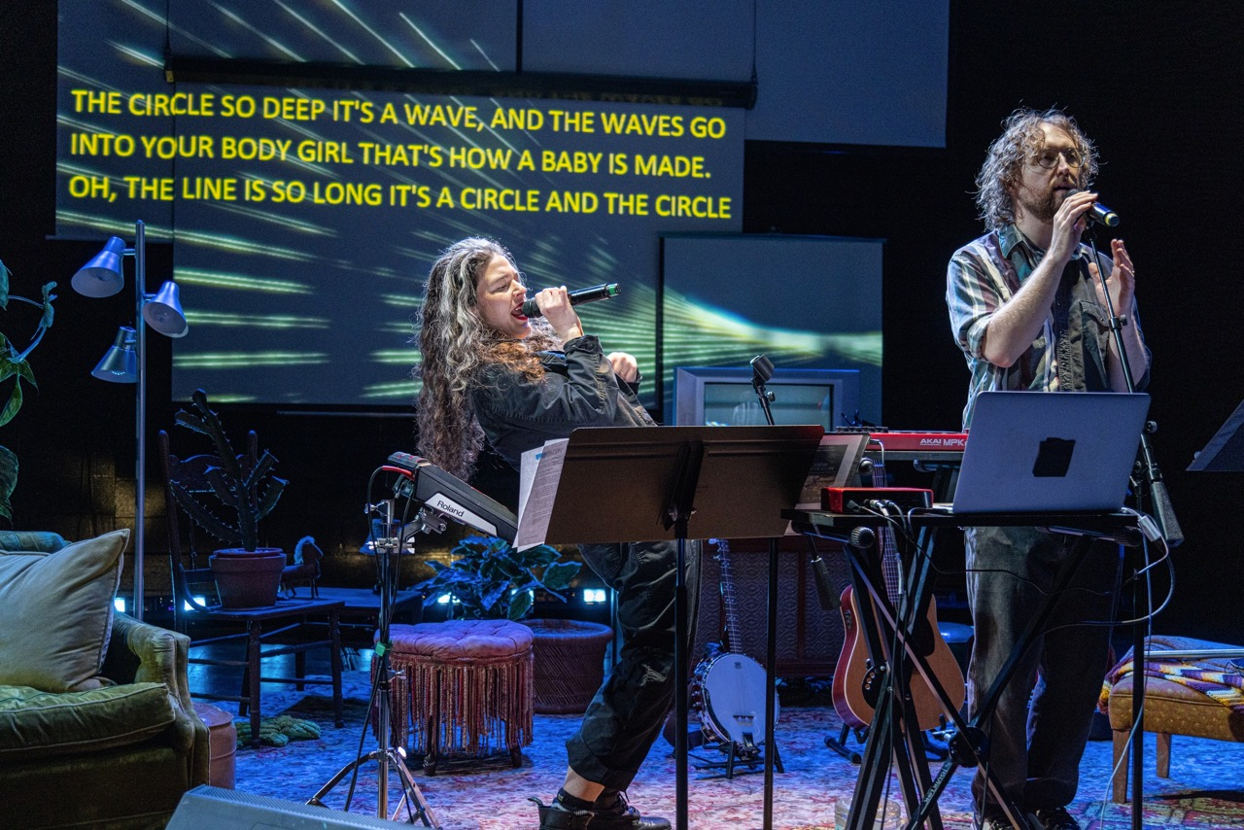
Figure 13. Abigail and Shaun Bengson in “Ohio” by The Bengsons. Actors Theatre of Louisville, January 2023. Photo Credit: Two Hearts Media–Yero
Figure 13 Image Description (ID): Two people holding microphones stand amongst living room furniture and musical instruments. Music stands are in front of them, a screen with yellow words as captions is behind them. From L to R: A person with light skin and long, wavy black and gray hair leans backwards while singing into a microphone. Another person with glasses and short, light curly hair and a beard stands up straight at a microphone stand, one hand holding the mic.

Dark Disabled Stories
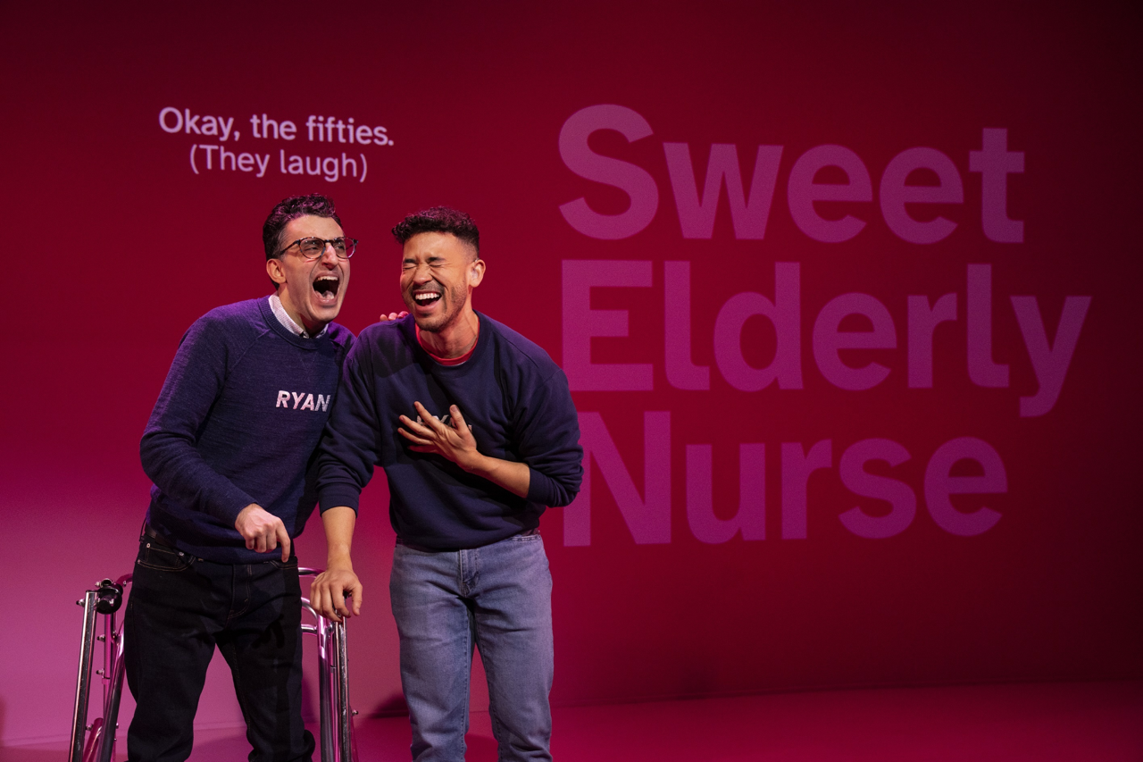
Figure 14. Ryan J. Haddad and Dickie Hearts in “Dark Disabled Stories” by Ryan J. Haddad,. The Public Theatre 2023. Photo Credit: Joan Marcus
Figure 14 Image Description (ID): Two people wearing sweaters with the word, “Ryan” on them stand side by side in front of a pink screen with white captions projected on it. From L to R: A person with glasses stands in front of a walker. Their hand resting on the shoulder of another person, whose dressed the same. Both are laughing.

Further Resources

Consulting/Services
ConsultAbility
Calling Up Justice
The Curiosity Paradox
Intimacy Coordinators of Color
Kentucky Commission of the Deaf and Hard of Hearing
Pro Bono ASL

Additional Viewings
Code of the Freaks (2022)
Crip Camp (2020)
Sins Invalid: An Unshamed Claim to Beauty (2013)
Vital Signs: Crip Culture Talks Back (1995)

Additional Readings
The Ableist Effects of Creating “Post-Pandemic Theatre” During a Pandemic by Allie Marotta (essay)
Autistics Unmasked and co-founder Ky Kennedy
Disability and Management by Nicole Kelly and Jenn Poret (essay)
Disability, Identity, and Representation: Notes from a Dramaturg by Andrea Kovich (essay)
The Importance of Including the Disabled Designers by Michael Maag and Mallory K. Nelson (essay)
Nick Walker’s writings, including “Neuroqueer Heresies” (book) Author, Educator, Queer futurist, and transpersonal somatic psychologist. Neuroqueer Heresies
Practicing Disability Justice, Honoring Wholeness by Lydia X.Z. Brown (essay)
Producing with a Disabled Lens by Claudia Alick (essay)
Puppetry and Disability Aesthetics by Marina Tsaplina (essay)
Rejecting Local and National Borders in La Carpa de la Frontera by Maria Patrice Amon (essay)
Sonny Jane Wise, Lived Experience Educator
Theatre of the Unimpressed by Jordan Tannahill (book)
“Unmasking Autism: Discovering The New Faces of Neurodiversity” by Devon Price (Book)
“We Are Not Broken: Changing the Autism Conversation” by Eric Garcia (Book)

Works Cited
Access Living. (2023). Guide: Planning an accessible virtual event. Access Living. https://www.accessliving.org/newsroom/guide-planning-an-accessible-virtual-event/
Alick, C. (2021). Day one: 30 Days of racial and disabled justice. Calling Up Justice! https://callingupjustice.com/day-one-30-days-of-racial-and-disabled-justice/
Bartlett, J., Black, S., Northen, M., & Lewis, T. (2011). Disablism. In Beauty is a verb: The new poetry of disability. essay, Cinco Puntos Press.
Bechdel, A. (2005). The rule. dykestowatchoutforcom RSS. https://dykestowatchoutfor.com/the-rule/
Berne, Patricia, & Harwell, L. (2021). Disability Justice 101. Sins Invalid in conversation with Ford Foundation.
Berne, Patricia, Morales, A. L., Langstaff, D., & Invalid, S. (2018). Ten principles of disability justice. WSQ: Women’s Studies Quarterly, 46(1–2), 227–230. https://doi.org/10.1353/wsq.2018.0003
Berne, Patty. (2019). Skin, tooth, and bone: The basis of movement is our people: A disability justice primer. Sins Invalid.
CAST. (2023). Until learning has no limits®. CAST. https://www.cast.org/
Centers for Disease Control and Prevention. (2023). Data & statistics on autism spectrum disorder. Centers for Disease Control and Prevention. https://www.cdc.gov/ncbddd/autism/data.html
Crenshaw, K. (1989). Demarginalizing the intersection of race and sex: A black feminist critique of antidiscrimination doctrine, feminist theory, and antiracist politics [1989]. University of Chicago Legal Forum, 1989(1), 139–167.
Curiosity Paradox, The. (2023). Access check-ins for facilitators: Reinvent the Wheel Every Time. The Curiosity Paradox. https://thecuriosityparadox.com/wheel
Davidson, K. (2015). Tales from the Trich. Tumblr. https://livenottopull.tumblr.com/post/134370618484/dream-you-were-meant-to-be-courageous-kitay
Deerinwater, J. (2023). Jen Deerinwater Twitter Account. Twitter. https://twitter.com/JenDeerinwater/status/1648786735202205696
Fries, K. (2017). The Fries test: On disability representation in our culture. Medium. https://medium.com/@kennyfries/the-fries-test-on-disability-representation-in-our-culture-9d1bad72cc00
Keenan, H. B. (2022). A Pedagogical Reflection and Syllabus Excerpt . In Lessons in liberation: An abolitionist toolkit for educators. essay, AK Press.
Kling, K. (2014). Work your quirk: the power of the disability art community. Tikkun Magazine, (Disability Justice and Spirituality).
McRae, T. A. (2017). Creative Access: Accommodations for Professional Performers with Disabilities. HowlRound. https://howlround.com/creative-access
Mingus, M. (2011). Access Intimacy: The Missing Link [web log]. Retrieved from https://leavingevidence.wordpress.com/2011/05/05/access-intimacy-the-missing-link/.
National Disability Authority. (n.d.). The 7 principles. Centre for Excellence in Universal Design. https://universaldesign.ie/what-is-universal-design/the-7-principles/the-7-principles.html
Okun, T. (1999). White Supremacy Culture. In Dismantling Racism Works (Ed.), Dismantling Racism Works web workbook. essay, dRworks.
Penoi, R. (2023). Restorying Our Past and Present, Imagining Our Future. Howlround Theatre Commons.
Peoples Hub. (n.d.). Disability justice and access. PeoplesHub. https://www.peopleshub.org/disability-justice-and-access
Piepzna-Samarasinha, L. L. (2021). Care work dreaming disability justice. Arsenal Pulp Press.
Schalk, S. (2022). Black disability politics. DUKE UNIVERSITY PRESS.
Siebers, T. (2010). Disability aesthetics. University of Michigan Press.
Taylor, S. (2019). Beasts of burden: Animal and disability liberation. Atlantic Provinces Special Education Authority, Library.
Torelli-Pedevska, M., & Siegel, R. (2023). “hire disabled writers, not just a disability consultant,” demands letter from dozens of creators. Variety. https://variety.com/2023/film/opinion/disabled-writers-hiring-disability-consultants-1235560905/?sub_action=logged_in
U.S. Dept. of Labor. (n.d.). Introduction to the Americans with disabilities act. ADA.gov. https://www.ada.gov/topics/intro-to-ada/

